**Python: open Anaconda → Jupyter Notebook**

**Week 1**

**Types**

A type is how Python represents different types of data.

|  |  |  |
| --- | --- | --- |
| **Expression** | **Data types** | **Means** |
| type(11)  type(0) | int | Integers, целое число, can be negative or positive |
| type(21.213)  type(3.12323) | float | Real numbers, include numbers between integers, дробные числа |
| type(“Hello Python 101”) | str | words |

**Typecasting** — change the type of an expression in Python. Examples:

* **Int 2 to float 2.0:** float(2):2.0
* **Float 1.1 to 1:** float(1.1):1
* **If a string contains an integer value you can convert it to int:** int(‘1’):1
* **If we convert a string that contains non**-integer value we get an error: int(‘A’):Error
* **Example**: int(3.99):3
* **Convert int to a string**: str(1):”1”
* **Convert float to a string**: str(4.5):’4.5’

**Boolean** is another **type** of Python. Can have two values: True and False:

* type(True):bool

Use propercase **True** and **False** to avoid error for Boolean.

**Expressions and Variables**

**Expressions** — **type** of operations a computer performs.

E.g. 43+60+16+41: numbers are **operands** and +/-/*/division signs are **operators**. Use double slash for round-up e.g. 25//6 = 4 vs 25/6 = 4.166…

**Variables**: can be used to store values. E.g. **my_variable=1**. You can use that variable later in the code by typing its name. You can later update the value of the variable. E.g. **my_variable=10**.

* x = 43 + 60 + 16 + 41
* x = 160
* y = x/60
* y:2.666…
* x=x/60
* x:2.666. The old value of x is not important.
* type(x):float
* total_min = 43 + 42 + 57 convert minutes
* total_hr = total_min / 60
* total_hr:2.367 to hours
* print(‘Hello, Ptyhon!’) Hello, Python!
* import sys check the Python version
* print(sys.version)
* import sys information about float numbers in the system
* print(sys.float_info)
* *or simply* sys.float_info
* int(‘1 or 2 people’) will result in an error

Use **symbol # for comments**. E.g. everything after # is a comment.

Strings can be represented with ‘’ quotes or “”.

**Strings**

Strings can be numerated in the following way:

“Name” = “1 2 3 4”

“Name” = “-4 -3 -2 -1”

That helps to reference to a specific part of a string:

* name = “Michael Jackson”

name[0]

‘M’

* name = “Michael Jackson”

name[-2]

‘o’

* name = “Michael Jackson”

name[0:4]

‘Mich’

Select every X value:

* name = “Michael Jackson”

name[::2]

‘McalJcsn’

Select every X value up to index 4:

* name = “Michael Jackson”

name[0:5:2]

‘Mca’

Obtain length:

* len(‘Michael Jackson’)

15

Group:

* name = 'Stefan Vanli'

statement = name + ' is geboren op 10 september'

statement

'Stefan Vanli is geboren op 10 september'

Multiply:

* name * 3
* 'Stefan VanliStefan VanliStefan Vanli'

Escape sequences (create new line):

* print(‘Stefan Vanli\nwoont in Rotterdam’)

‘Stefan Vanli

woont in Rotterdam’

* print(‘Stefan Vanli \n woont in Rotterdam’) *# it includes space*

‘Stefan Vanli

woont in Rotterdam’

Tab:

* print(‘Stefan Vanli\twoont in Rotterdam’)

‘Stefan Vanli woont in Rotterdam’

Insert backslash:

* print(‘Stefan Vanli \\ woont in Rotterdam’)

‘Stefan Vanli \ woont in Rotterdam’

* print(r‘Stefan Vanli \ woont in Rotterdam’) # place r before the string

‘Stefan Vanli \ woont in Rotterdam’

**Methods**

Upper/lowercase:

* A = ‘Thriller is the sixth studio album’

B = A.upper() *# or lower()*

B

‘THRILLER IS THE SIXTH STUDIO ALBUM’

Replace:

* A = 'Stefan Vanli woont in Warschau'

B = A.replace('Warschau', 'Rotterdam')

B

Find:

* A = ‘Stefan Vanli will live in Amsterdam’

A.find(‘Amsterdam’)

26 # output is the first index of the sequence

A.find(‘z’)

-1 # output is -1 if you cannot find it in the string

**Week 2**

**Lists and Tuples**

Tuples are an ordered sequence. Example:

**Ratings = (10, 9, 6, 5, 10, 8, 9, 6, 2)**

It can contain various data types:

**tuple1 = (‘word’, 10, 1.2)**

Type of a tuple is a tuple:

**Type(tuple1) = tuple**

Every element of the tuple can be accessed:

**tuple1[0]: ‘word’**

**tuple1[1]: 10**

**tuple1[-1]: 1.2**

Combine tuples:

**Tuple2 = tuple1 + (‘hard rock’, 10)**

**Tuple2**

**(‘word’, 10, 1.2, ‘hard rock’, 10)**

Slicing also works for tuples (the first index [0:3] calculate from 0, second index [0:3] calculate from 1):

**tuple2[0:3]: (‘word’, 10, 1.2)**

Length of the tuple:

**len((‘word’, 10, 1.2, ‘hard rock’, 10)): 5**

Tuples are immutable, we cannot change them. If we want to change a tuple we need to create a new one.

Sort a tuple:

**Ratings = (10, 9, 6, 5, 10, 8, 9, 6, 2)**

**RatingsSorted = sorted(Ratings)**

**(2, 5, 6, 6, 8, 9, 9, 10, 10)**

A tuple can contain other tuples (it can be nested):  
**NT = (1, 2, (‘pop’, ‘rock’), (3, 4), (‘disco’, (1, 2)))**

**0 1 2 3 4**

To access data within a nested tuple:

**NT[2]: ‘pop’, ‘rock’**

**NT[2][1]: ‘rock’**

**NT[2][1][1]: ‘o’**

Lists are ordered sequences. In many ways they are like tuples but they are mutable. They can nest str, float, int, lists, and tuples:

**L = [‘Michael Jackson’, 10.1, 1982]**

**L = [‘Michael Jackson’, 10.1, 1982, [1, 2], (‘A’, 1)]**

**L[1]: 10.1**

Lists are mutable, to extend a list use the following command:

**L.extend([‘pop’, 10])**

**[‘Michael Jackson’, 10.1, 1982, ‘pop’, 10]**

To add one element:

**L.append([‘pop’, 10])**

**[‘Michael Jackson’, 10.1, 1982, [‘pop’, 10]]**

Change lists:

**A = [‘disco’, 10, 1.2]**

**A[0] = ‘hard rock’**

**[‘hard rock’, 10, 1.2]**

Delete an element:

**A = [‘disco’, 10, 1.2]**

**del(A[0])**

**[10, 1.2]**

Convert string to list:

**‘hard rock’.split()**

**[‘hard’, ‘rock’]**

Separate on a specific symbol (delimiter):

**‘A, B, C, D’.split(‘,’)**

**[‘A’, ‘B’, ‘C’, ‘D’]**

If you reference **A = X** and **B = A** and then change **X** to **Z**, then the result of B also changes from **X** to **Z**.

To clone a list do the following:

**A = [‘disco’, 10, 1.2]**

**B = A[:]**  in that case if we change values in A values in B will not change

Get help on a list:

**list = [1, 2, 3]**

**help(list)**

Find the first index of ‘disco’ in a tuple:

**genres_tuple = ("pop",**

**"rock",**

**"soul",**

**"hard rock",**

**"soft rock",**

**"R&B",**

**"progressive rock",**

**"disco")**

**genres_tuple.index(‘disco’)**

**7**

The address of each element within a list is called an index. An index is used to access and refer to items within a list.

**Tuple = (1, 2, 3)**

**List = [1, 2, 3]**

Change elements:

**profile = ['Stefan', 'Vanli', 'male', 29, 'Moscow', 'Russian']**

**print('Before change:', profile)**

**profile[0] = 'Alena'**

**profile[2] = 'female'**

**profile[5] = 'Polish'**

**print('After change: ', profile)**

Before change: ['Stefan', 'Vanli', 'male', 29, 'Moscow', 'Russian']

After change: ['Alena', 'Vanli', 'female', 29, 'Moscow', 'Polish']

Delete elements:

**print('Before change:', profile)**

**del(profile[5])**

**print('After change:', profile)**

Before change: ['Alena', 'Vanli', 'female', 29, 'Moscow', 'Polish']

After change: ['Alena', 'Vanli', 'female', 29, 'Moscow']

To split a string into a list:

**colors_list = 'Red white blue orange yellow pink purple'.split()**

**colors_list**

['Red', 'white', 'blue', 'orange', 'yellow', 'pink', 'purple']

To split using a delimiter:

**'red, blue, orange, white, yellow'.split(',')**

['red', ' blue', ' orange', ' white', ' yellow']

To create a copy (clone) of a list:

**A = [1, 2, 3, 4, 5]**

**B = A**

**B = A[:]**

**B[0] = 6**

**print(A)**

**print(B)**

[1, 2, 3, 4, 5]

[6, 2, 3, 4, 5]

**Dictionaries**

Dictionaries are denoted with curly Brackets {}.

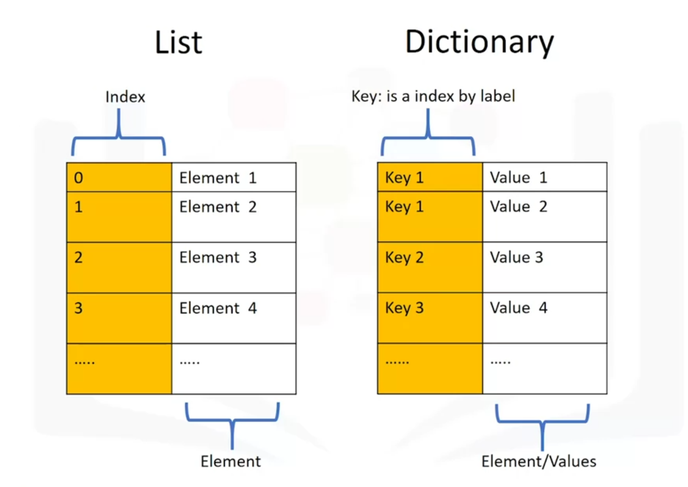

Keys in dictionaries have to be immutable and unique. The values can be immutable, mutable and duplicates.

**{‘key1’:1, ‘key2’: ‘2’, ‘key3’: [3,3,3], ‘key4’: (4,4,4), (‘key5’):5}**

**DICT = {'Thriller': 1982, 'Back in Black': 1980, 'The Dark Side of the Moon': 1973, 'The Bodyguard': 1992}**

**DICT**

{'Thriller': 1982,

'Back in Black': 1980,

'The Dark Side of the Moon': 1973,

'The Bodyguard': 1992}

**DICT['Thriller']**

1982

Add a row to the dictionary:

**DICT[‘Graduation’] = ‘2007’**

To delete a value in the dictionary:

**del(DICT['Graduation'])**

**DICT**

{'Thriller': 1982,

'Back in Black': 1980,

'The Dark Side of the Moon': 1973,

'The Bodyguard': 1992}

To find something in a dictionary:

**‘Thriller’ in DICT**

True

To get all the keys (the output is a list):

**DICT.keys()**

dict_keys(['Thriller', 'Back in Black', 'The Dark Side of the Moon', 'The Bodyguard'])

List of values:

**DICT.values()**

dict_values([1982, 1980, 1973, 1992])

Each key is separated from its value by a colon ":". Commas separate the items, and the whole dictionary is enclosed in curly braces. An empty dictionary without any items is written with just two curly braces, like this "{}".

**Sets**

Sets are a type of collection. You can input different Python types. Unlike lists and tuples they are unordered: sets do not record element position. It has only unique elements.

A set is a unique collection of objects in Python. It is denoted with {}, it removes duplicate values, and it is case-sensitive.

Example:

**set_example = {'Stefan', 'Alena', 'John', 'Serge', 'Alena', 'Adam'}**

**set_example**

{'Adam', 'Alena', 'John', 'Serge', 'Stefan'}

Same set with a different first letter:

**set_example = {'Stefan', 'alena', 'John', 'Serge', 'Adam'}**

**set_example**

{'Adam', 'John', 'Serge', 'Stefan', 'alena'}

Converst list to set:

**list = ('Stefan', 'Alena', 'John', 'Serge', 'Alena', 'Adam')**

**set_list = set(list)**

**set_list**

{'Adam', 'Alena', 'John', 'Serge', 'Stefan'}

Define a set:

NamesSet2 = set(['Stefan', 'Alena', 'Ivan', 'Joe', 'Serge', 'Ian', 'Ivan'])

NamesSet2

{'Alena', 'Ian', 'Ivan', 'Joe', 'Serge', 'Stefan'}

Add/remove element to a set:

**NamesSet2.add('Adam') NamesSet2.remove('Adam')**

**NamesSet2**

{'Adam', 'Alena', 'Ian', 'Ivan', 'Joe', 'Serge', 'Stefan'}

Check if there is a value in a set:

**'Alena' in NamesSet2**

False

You can check the difference between sets, as well as the symmetric difference, intersection, and union.

Print 3 sets:

**name_set_1 = {'Adam', 'Alena', 'Ian', 'Ivan', 'Joe', 'Serge', 'Stefan'}**

**name_set_2 = {'Adam', 'Alena', 'John', 'Bob', 'Irene', 'Maria', 'Stefan'}**

**name_set_3 = {'Alex', 'Tadeusz', 'Remigiusz', 'Tomasz', 'Irene', 'Maria', 'Stefan'}**

**name_set_1, name_set_2, name_set_3**

({'Adam', 'Alena', 'Ian', 'Ivan', 'Joe', 'Serge', 'Stefan'},

{'Adam', 'Alena', 'Bob', 'Irene', 'John', 'Maria', 'Stefan'},

{'Alex', 'Irene', 'Maria', 'Remigiusz', 'Stefan', 'Tadeusz', 'Tomasz'})

Show values that are in both sets (inner join):

**intersection = name_set_1 & name_set_2** or **name_set_1.intersection(name_set_2)**

**intersection**

{'Adam', 'Alena', 'Stefan'}

Show values that are unique in first set (left join):  
**name_set_1.difference(name_set_2)**

{'Ian', 'Ivan', 'Joe', 'Serge'}

Show values that are unique in second set (right join):

**name_set_2.difference(name_set_1)**

{'Bob', 'Irene', 'John', 'Maria'}

Full join:

**name_set_1.union(name_set_2)**

{'Adam',

'Alena',

'Bob',

'Ian',

'Irene',

'Ivan',

'Joe',

'John',

'Maria',

'Serge',

'Stefan'}

Check if a set is a superset or subset of another set:

**set(name_set_1).issuperset(name_set_2) set(name_set_2).issubset(name_set_1)**

False False

**set({'Adam', 'Alena', 'Stefan'}).issubset(name_set_1)**

True

**name_set_1.issuperset({'Stefan', 'Alena'})**

True

Same numbers in a list and in a set do not always lead to a same result:

**A = [1, 2, 2, 1]**

**B = set([1, 2, 2, 1])**

**print('Sum of list:', sum(A))**

**print('Sum of set: ', sum(B))**

Sum of list: 6

Sum of set: 3

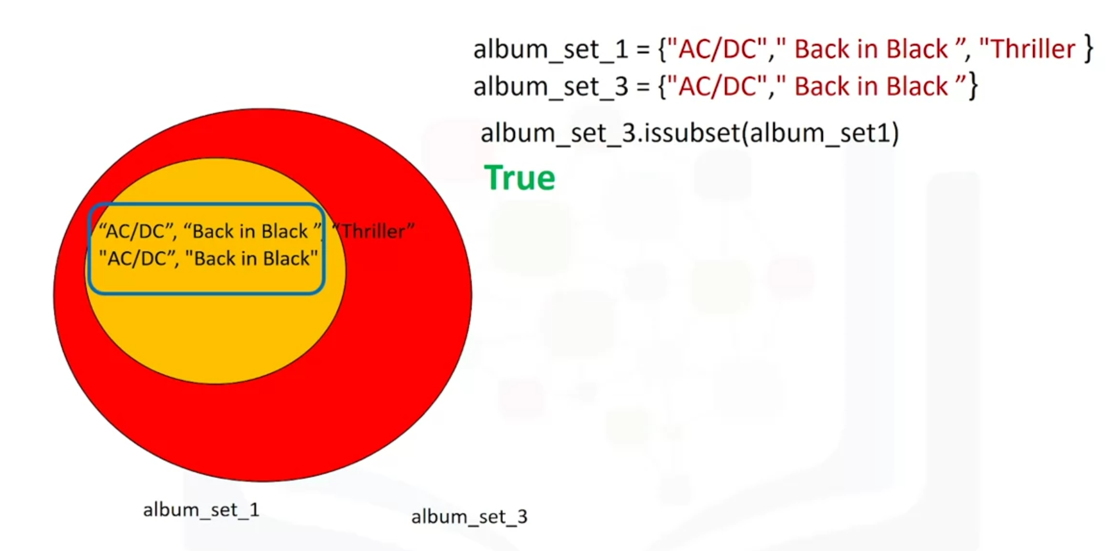

**Week 3**

**Conditions and Branching**

**Comparison Operators**

Operators for comparing two values:

* equal: **==**
* not equal: **!=**
* greater than: **>**
* less than: **<**
* greater than or equal to: **>=**
* less than or equal to: **<=**

Check if a value is equal to a different value:

**a = 5**

**a == 6 a != 6 a > 3**

False True True

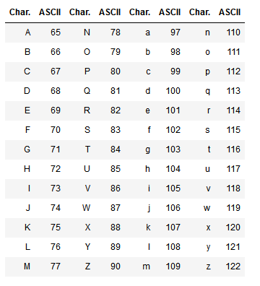

**'B' > 'A'**

True

B is 66 and A is 65 in the ASCII. Therefore it is ‘larger’.

When there are multiple letters, the first letter takes precedence in ordering:

**'BA' > 'AB'**

True

Upper Case Letters have different ASCII code than Lower Case Letters, which means the comparison between the letters in Python is case-sensitive.

**Branching**

# First you set the age, in this case 30.

**age = 30**

# You set the first condition. If a person is 65 or older he will be offered the retirement course.

**if age >= 65:**

**print('1. Check the retirement course.')**

# If the visitor is younger he will get a different suggestion based on his age.

**elif age >= 50:**

**print('1. Check the "Dealing with teens" course.')**

**elif age == 30:**

**print('1. Check the "Getting older" course.')**

**elif age >= 25:**

**print('1. Check the "Finding your first job" course.')**

**elif age >= 18:**

**print('1. Check the university course.')**

# If the visitor does not fit any other category he will be offered the school course.

**else:**

**print('1. Check the school course.')**

# When the visitor is done with the course he will get this message.

**print('2. Thanks for your visit! Come back soon to the Rotterdam Community Center.')**

1. Check the "Getting older" course.

2. Thanks for your visit! Come back soon to the Rotterdam Community Center.

An if statement:

# Set the employee age.

**age_emp = 25**

# If the employee is 40 or older print this message.

**if age_emp >= 40:**

**print('Employee is 40 or older.')**

# If the employee is 30 or older print this message.

**elif age_emp >= 30:**

**print('Employee is 30 or older.')**

# If the employee is younger than 30 print this message.

**else:**

**print('Employee is younger than 30.')**

Employee is younger than 30.

Example of not:

**album_year = 1983**

**if not (album_year == '1984'):**

**print ("Album year is not 1984")**

Album year is not 1984

Write an if statement to determine if an album came out before 1980 or in the years: 1991 or 1993. If the condition is true print out the year the album came out.

**album_year = 1960**

**if (album_year < 1980) or (album_year == 1991) or (album_year == 1993):**

**print('This album came in the', album_year, 'year.')**

This album came in the 1960 year.

**Loops**

Sometimes you might want to repeat a given operation many times. Repeated executions like this are performed by loops. Two types of loops will be discussed: *for* loops and *while* loops. The for loop is used for a controlled flow of repetition.

If we want to keep executing a code block until a certain condition is met we use the *while* loop. The while loop exists as a tool for repeated execution based on a condition. The code block will keep being executed until the given logical condition returns a **False** boolean value.

**Range**

Range is an ordered list. To generate an object that contains elements ordered from 0 to 9 use the following command:

**range(10)**

range(0, 10)

Range example:

**Range(N) range(3) range(10, 15)**

[0, …, N-1] [0, 1, 2] [10, 11, 12, 13, 14]

The for loop enables you to execute a code block multiple times. For example, you would use this if you would like to print out every element in a list.

For loop examples:

**dates = [1992, 1993, 1994]**

**n = len(dates)**

**for x in range(n):**

**print(dates[x])**

1992

1993

1994

**random_text = ['ddawd', 'uivfd', '32dw38k', 'd32ijd239']**

**n = len(random_text)**

**for x in range(n):**

**print(random_text[x])**

ddawd

uivfd

32dw38k

d32ijd239

In Python we can directly access the elements in the list as follows:

**employees = [32, 33, 43, 23, 43, 45, 45, 34]**

**for age in employees:**

**print(age)**

32

33

43

23

43

45

45

34

**random = ['dawd', 'awdawd', 'difeij', 'dwij32id', 323]**

**for uihawiu in random:**

**print(uihawiu)**

dawd

awdawd

difeij

dwij32id

323

Change the elements in a list:

**names_list = ['Stefan', 'Alex', 'Tom', 'Jake']**

**n = len(names_list)**

**for names in range(n):**

**print('01.01.22:', names_list[names])**

**names_list[names] = 'Deleted'**

**print('01.02.22:', names_list[names])**

01.01.22: Stefan

01.02.22: Deleted

01.01.22: Alex

01.02.22: Deleted

01.01.22: Tom

01.02.22: Deleted

01.01.22: Jake

01.02.22: Deleted

Access the index and the elements of a list:

**names_list = ['Stefan', 'Alex', 'Tom', 'Jake']**

**for n, names in enumerate(names_list):**

**print(n, names)**

0 Stefan

1 Alex

2 Tom

3 Jake

# While Loop Example

**dates = [1982, 1980, 1973, 2000]**

**x = 0**

**y = dates[0]**

**while(y != 1973):**

**print(y)**

**x = x + 1**

**y = dates[x]**

**print("It took ", x ,"repetitions to get out of loop.")**

1982

1980

It took 2 repetitions to get out of loop.

A while loop iterates merely until the condition in the argument is not met.

Copy the ‘Stefan’ values from the first list to the second. Stop the copy when the first value is not ‘Stefan’:

**name_list = ['Stefan', 'Stefan', 'Stefan', 'Stefan', 'Stfan', 'Stefan', 'Stefan']**

**new_name_list = []**

**x = 0**

**while(name_list[x] == 'Stefan'):**

**new_name_list.append(name_list[x])**

**x = x + 1**

**print(name_list)**

**print(new_name_list)**

['Stefan', 'Stefan', 'Stefan', 'Stefan', 'Stfan', 'Stefan', 'Stefan']

['Stefan', 'Stefan', 'Stefan', 'Stefan']

**Functions and Variables**

**Functions**

A function is a reusable block of code which performs operations specified in the function. They let you break down tasks and allow you to reuse your code in different programs. Two types of functions:

* Pre-defined functions
* User defined functions

You can define functions to provide the required functionality. Here are simple rules to define a function in Python:

* Functions blocks begin def followed by the function name and parentheses ().
* There are input parameters or arguments that should be placed within these parentheses.
* You can also define parameters inside these parentheses.
* There is a body within every function that starts with a colon (:) and is indented.
* You can also place documentation before the body.
* The statement return exits a function, optionally passing back a value.

Function example:

**def add(a):**

**"""**

**add 1 to a**

**"""**

**b = a + 1**

**print(a, "if you add one", b)**

**return(b)**

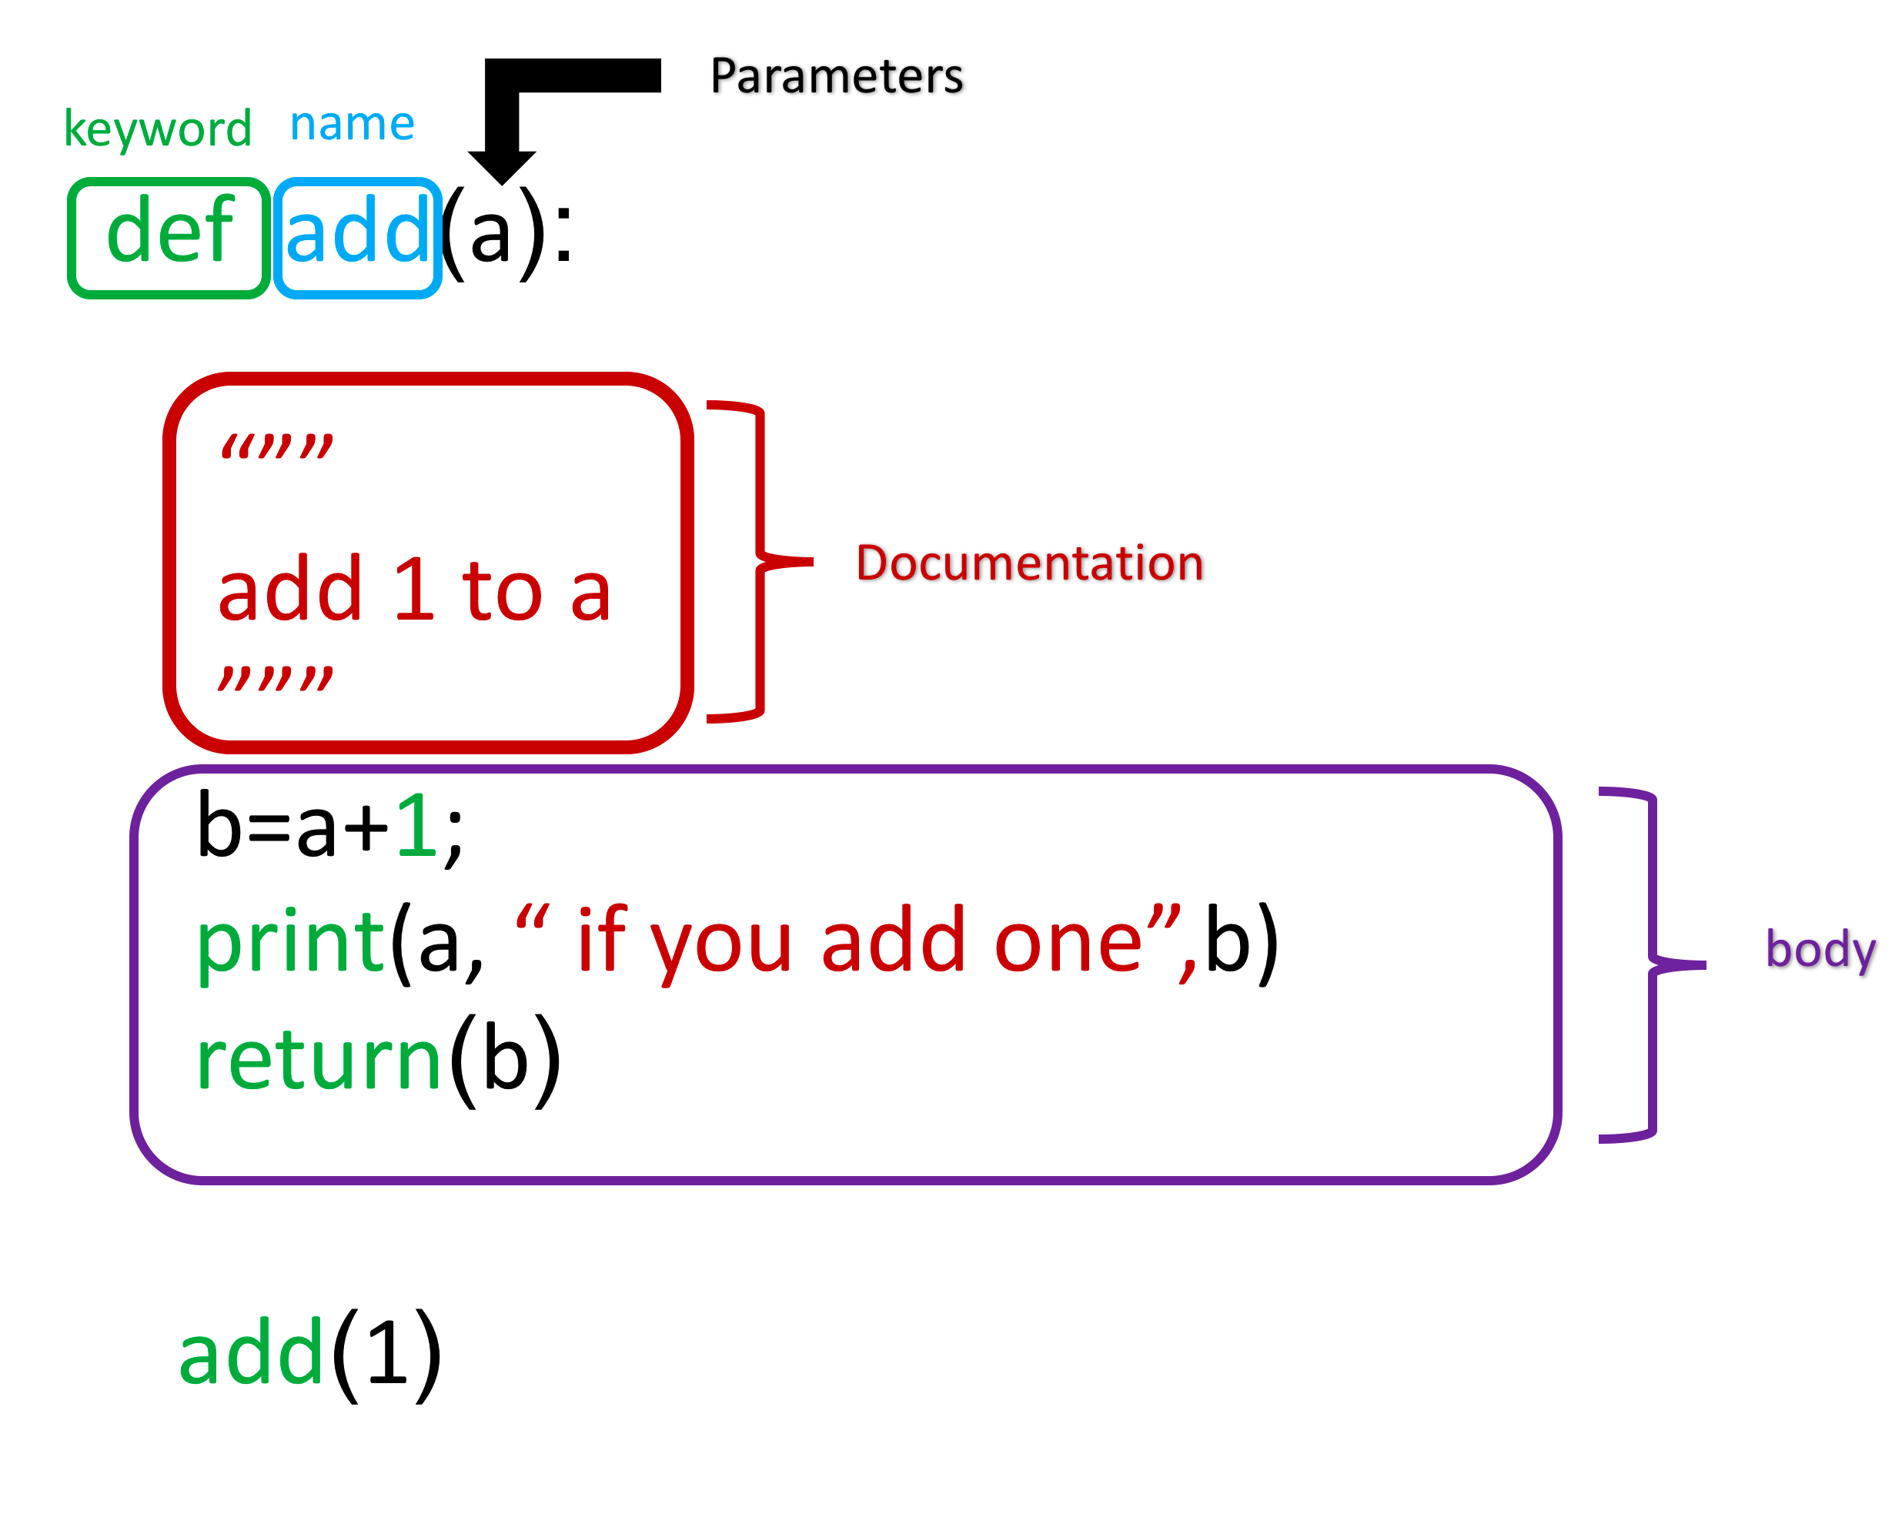

Obtain help about a function:

**help(add)**

Call the function:

**add(1)**

1 if you add one 2

2

Call the function second time:

**add(2)**

2 if you add one 3

3

Define a function:

**def m (a, b):**

**c = a * b**

**print(c)**

**print('Text is printed if there is no [return] line.')**

**m (2, 4)**

8

Text is printed if there is no [return] line.

Same function with a return():

**def m (a, b):**

**c = a * b**

**return(c)**

**print('Text is not printed if there is a [return] line.')**

**m (2, 4)**

8

**Variables**

The input to a function is called a formal parameter.

A variable that is declared inside a function is called a local variable. The parameter only exists within the function (i.e. the point where the function starts and stops).

A variable that is declared outside a function definition is a global variable, and its value is accessible and modifiable throughout the program

The local variable is b:

**def square (a):**

**b = 3**

**c = a * a + b**

**print ('Square of', a, 'plus 3 gives us:')**

**return (c)**

**square (4)**

Square of 4 plus 3 gives us:

19

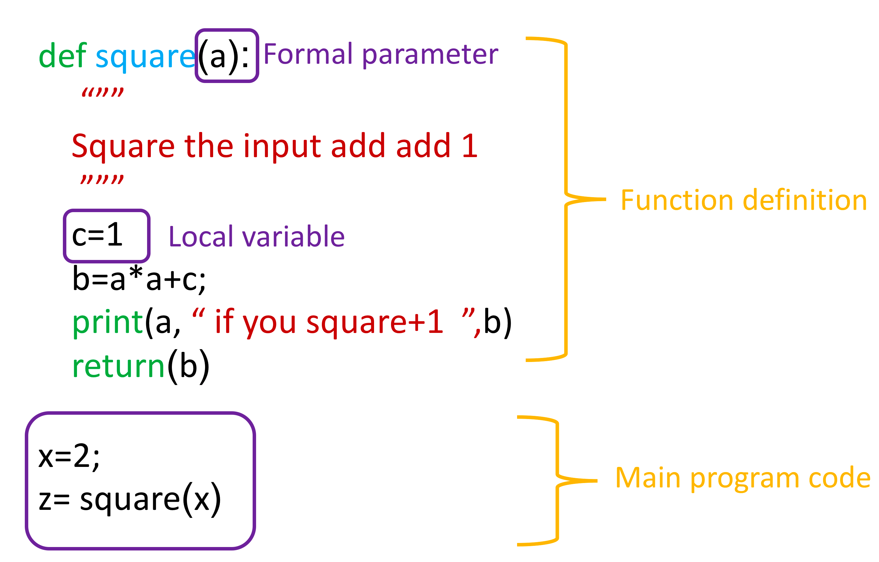

Global variable example:

**x = 5**

**square (x)**

Square of 5 plus 3 gives us:

28

If there is no *return* statement, the function returns *None*. The following two functions are equivalent:

**def MJ():**

**print('Michael Jackson')**

**def MJ1():**

**print('Michael Jackson')**

**return(None)**

**MJ()**

Michael Jackson

**MJ1()**

Michael Jackson

Printing the function after a call reveals a **None** is the default return statement:

**print(MJ())**

**print(MJ1())**

Michael Jackson

None

Michael Jackson

None

Combine values:

**def concatenate (a, b):**

**return (a + b)**

**concatenate (4, 12)**

16

Concatenate example:

**def concatenate (a, b, c):**

**return (a + b + c)**

**print (concatenate (4, 12, 31))**

**print ('\n')**

**print (concatenate ('Example', ' ', 'and Test'))**

47

Example and Test

Function with an if:

**def equation (a, b):**

**c = a + b + 2 * a * b - 1**

**if (c < 0):**

**c = 0**

**else:**

**c = 5**

**return(c)**

**print (equation (4, 5))**

**print (equation (0, 0))**

5

0

This function can be accessed the following way:

**a = 4**

**b = 5**

**c = equation (a, b)**

**c**

5

Print, sum and len are examples of pre-defined functions in Python.

**album_ratings = [10.0, 8.5, 9.5, 7.0, 7.0, 9.5, 9.0, 9.5]**

**print(album_ratings)**

[10.0, 8.5, 9.5, 7.0, 7.0, 9.5, 9.0, 9.5]

**sum(album_ratings)**

70.0

**len(album_ratings)**

8

**def candidate (name, surname, position, age):**

**print(position, '|', name, surname[0], '|', age)**

**if age < 30:**

**return print(name, 'could lack experience.')**

**else:**

**return print(name, 'could be a potential candidate.')**

**candidate ('John', 'Dougherty', 'Senior HR Specialist', 37)**

Senior HR Specialist | John D | 37

John could be a potential candidate.

Setting a default argument that is returned if no value is in the function:

**def isGoodRating(rating=4):**

**if(rating < 7):**

**print("this album sucks it's rating is",rating)**

**else:**

**print("this album is good its rating is",rating)**

**isGoodRating() ← no value**

**isGoodRating(10)**

this album sucks it's rating is 4

this album is good its rating is 10

**Global Variables**

Variables outside the function are called global variables.

Example of a global variable:

**artist = "Michael Jackson"**

**def printer1(artist):**

**internal_var1 = artist**

**print(artist, "is an artist")**

**printer1(artist)**

Michael Jackson is an artist

Create a global variable in a function:

**artist = "Michael Jackson"**

**def printer(artist):**

**global internal_var**

**internal_var= "Whitney Houston"**

**print(artist,"is an artist")**

**printer(artist)**

**printer(internal_var)**

Michael Jackson is an artist

Whitney Houston is an artist

Example of a global variable:

**WifeName = 'Alena Vanli'**

**def check (name):**

**if name == WifeName:**

**return 'my wife'**

**else:**

**return 'not my wife'**

**print ('Alena Vanli:', check ('Alena Vanli'))**

**print ('Maria Len: ', check ('Maria Len'))**

**print ('Alna Vanli: ', check ('Alna Vanli'))**

Alena Vanli: my wife

Maria Len: not my wife

Alna Vanli: not my wife

Deleting a variable:

**del myFavouriteBand**

Example of a local variable:

**# Deleting the variable "myFavouriteBand" from the previous example to demonstrate an example of a local variable**

**del myFavouriteBand**

**# Example of local variable**

**def getBandRating(bandname):**

**myFavouriteBand = "AC/DC"**

**if bandname == myFavouriteBand:**

**return 10.0**

**else:**

**return 0.0**

**print("AC/DC's rating is: ", getBandRating("AC/DC"))**

**print("Deep Purple's rating is: ", getBandRating("Deep Purple"))**

**print("My favourite band is", myFavouriteBand)**

---------------------------------------------------------------------------

NameError Traceback (most recent call last)

<ipython-input-4-263a05334c01> in <module>

1 # Deleting the variable "myFavouriteBand" from the previous example to demonstrate an example of a local variable

2

----> 3 del myFavouriteBand

4

5 # Example of local variable

NameError: name 'myFavouriteBand' is not defined

myFavouriteBand is a local variable and therefore it cannot be accessed in this way and it returns an error.

Where there is a global and a local variable with the same name:

**myFavouriteBand = "AC/DC"**

**def getBandRating(bandname):**

**myFavouriteBand = "Deep Purple"**

**if bandname == myFavouriteBand:**

**return 10.0**

**else:**

**return 0.0**

**print("AC/DC's rating is:",getBandRating("AC/DC"))**

**print("Deep Purple's rating is: ",getBandRating("Deep Purple"))**

**print("My favourite band is:",myFavouriteBand)**

AC/DC's rating is: 0.0

Deep Purple's rating is: 10.0 < local variable

My favourite band is: AC/DC < global variable

**Collections and Functions**

When the number of arguments are unknown for a function, They can all be packed into a tuple:

**def printAll(* args): # All the arguments are 'packed' into args which can be treated like a tuple**

**print("No of arguments:", len(args))**

**for argument in args:**

**print(argument)**

**#printAll with 3 arguments**

**printAll('Horsefeather','Adonis','Bone')**

**#printAll with 4 arguments**

**printAll('Sidecar','Long Island','Mudslide','Carriage')**

No of arguments: 3

Horsefeather

Adonis

Bone

No of arguments: 4

Sidecar

Long Island

Mudslide

Carriage

The arguments can also be packed into a dictionary as shown:

**def printDictionary(** args):**

**for key in args:**

**print(key + ": " + args[key])**

**printDictionary(Country='Canada',Province='Ontario',City='Toronto')**

Country: Canada

Province: Ontario

City: Toronto

Functions can be incredibly powerful and versatile. They can accept (and return) data types, objects and even other functions as arguments. Consider the example below:

**def addItems(list):**

**list.append("Three")**

**list.append("Four")**

**myList = ["One","Two"]**

**addItems(myList)**

**myList**

['One', 'Two', 'Three', 'Four']

This function can be used to concatenate lists of tuples:

**def con(a, b):**

**return(a + b)**

**con (['A', 'B', 'C'], [1, 2, 3])**

['A', 'B', 'C', 1, 2, 3]

The value of list L does not change since sorted is a function and it returns a new list and it does not change the original list L:

**L = [1, 3, 2]**

**print (sorted (L))**

**print (L)**

[1, 2, 3]

[1, 3, 2]

If we use the sort function it does not create a new list, it sorts the current list:

**L=[1,3,2]**

**print(sorted(L))**

**L.sort()**

**print(L)**

[1, 2, 3]

[1, 2, 3]

The function concatenates a string:

**def Print(A):**

**for a in A:**

**print(a+'1')**

**Print(['a','b','c'])**

a1

b1

c1

You need to have a *pass* if you have an empty function and you want to run it:

**def NoWork():**

**pass**

**print(NoWork())**

None

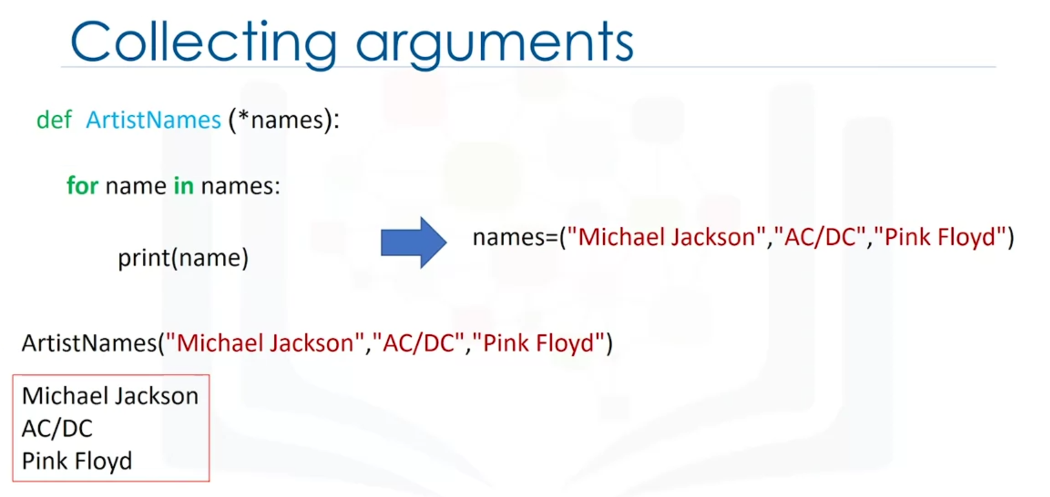

**Exception Handling**

An exception is an error that occurs during the execution of code. This error causes the code to raise an exception and if not prepared to handle it will halt the execution of the code.

[Built-in Exceptions in Python.](https://docs.python.org/3/library/exceptions.html?utm_medium=Exinfluencer&utm_source=Exinfluencer&utm_content=000026UJ&utm_term=10006555&utm_id=NA-SkillsNetwork-Channel-SkillsNetworkCoursesIBMDeveloperSkillsNetworkPY0101ENSkillsNetwork19487395-2021-01-01)

Example of exception handling:

**a = 100**

**try:**

**b = int(input ('Please enter a number to divide a: '))**

**a = a / b**

**print ('Success a = ', a)**

**except:**

**print ('There was an error')**

Please enter a number to divide a: 3

Success a = 33.333333333333336

Можно направлять пользователя если вылезает какая-то ошибка. Например тут три варианта ошибки есть:

**a = 1**

**try:**

**b = int(input("Please enter a number to divide a"))**

**a = a/b**

**print("Success a=",a)**

**except ZeroDivisionError:**

**print("The number you provided cant divide 1 because it is 0")**

**b = int(input("Try again. Please enter a number to divide a"))**

**a = a/b**

**print("Success a=",a)**

**except ValueError:**

**print("You did not provide a number")**

**b = int(input("Try again. Please enter a number to divide a"))**

**a = a/b**

**print("Success a=",a)**

**except:**

**print("Something went wrong")**

**b = int(input("Try again. Please enter a number to divide a"))**

**a = a/b**

**print("Success a=",a)**

Please enter a number to divide a

You did not provide a number

Try again. Please enter a number to divide a8

Success a= 0.125

Example of an inclusive error:

**a = 100**

**try:**

**b = int(input('INPUT\t Enter a number: '))**

**a = a / b**

**print("OUTPUT\t Your result: ", a)**

**except:**

**print("COMMENT\t Whoops, something went wrong. Please enter a full number like 3, 10, 234 to proceed with the calculation.")**

**b = int(input('INPUT\t Enter a number: '))**

**a = a / b**

**print("OUTPUT\t Your result: ", a)**

INPUT Enter a number: j

COMMENT Whoops, something went wrong. Please enter a full number like 3, 10, 234 to proceed with the calculation.

INPUT Enter a number: 87

OUTPUT Your result: 1.1494252873563218

else allows one to check if there was no exception when executing the try block. This is useful when we want to execute something only if there were no errors. finally allows us to always execute something even if there is an exception or not. This is usually used to signify the end of the try except.

Example of else:

**a = 1**

**try:**

**b = int(input("Please enter a number to divide a"))**

**a = a/b**

**except ZeroDivisionError:**

**print("The number you provided cant divide 1 because it is 0")**

**except ValueError:**

**print("You did not provide a number")**

**except:**

**print("Something went wrong")**

**else:**

**print("success a=",a)**

Please enter a number to divide a6

success a= 0.16666666666666666

Example of finally:

**a = 1**

**try:**

**b = int(input("Please enter a number to divide a"))**

**a = a/b**

**except ZeroDivisionError:**

**print("The number you provided cant divide 1 because it is 0")**

**except ValueError:**

**print("You did not provide a number")**

**except:**

**print("Something went wrong")**

**else:**

**print("success a=",a)**

**finally:**

**print("Processing Complete")**

Please enter a number to divide a6

success a= 0.16666666666666666

Processing Complete

**Classes and Objects**

The first step in creating a class is giving it a name. We need to determine all the data that make up that class, which we call attributes. The class Circle has the attribute radius and color, while the Rectangle class has the attribute height and width.

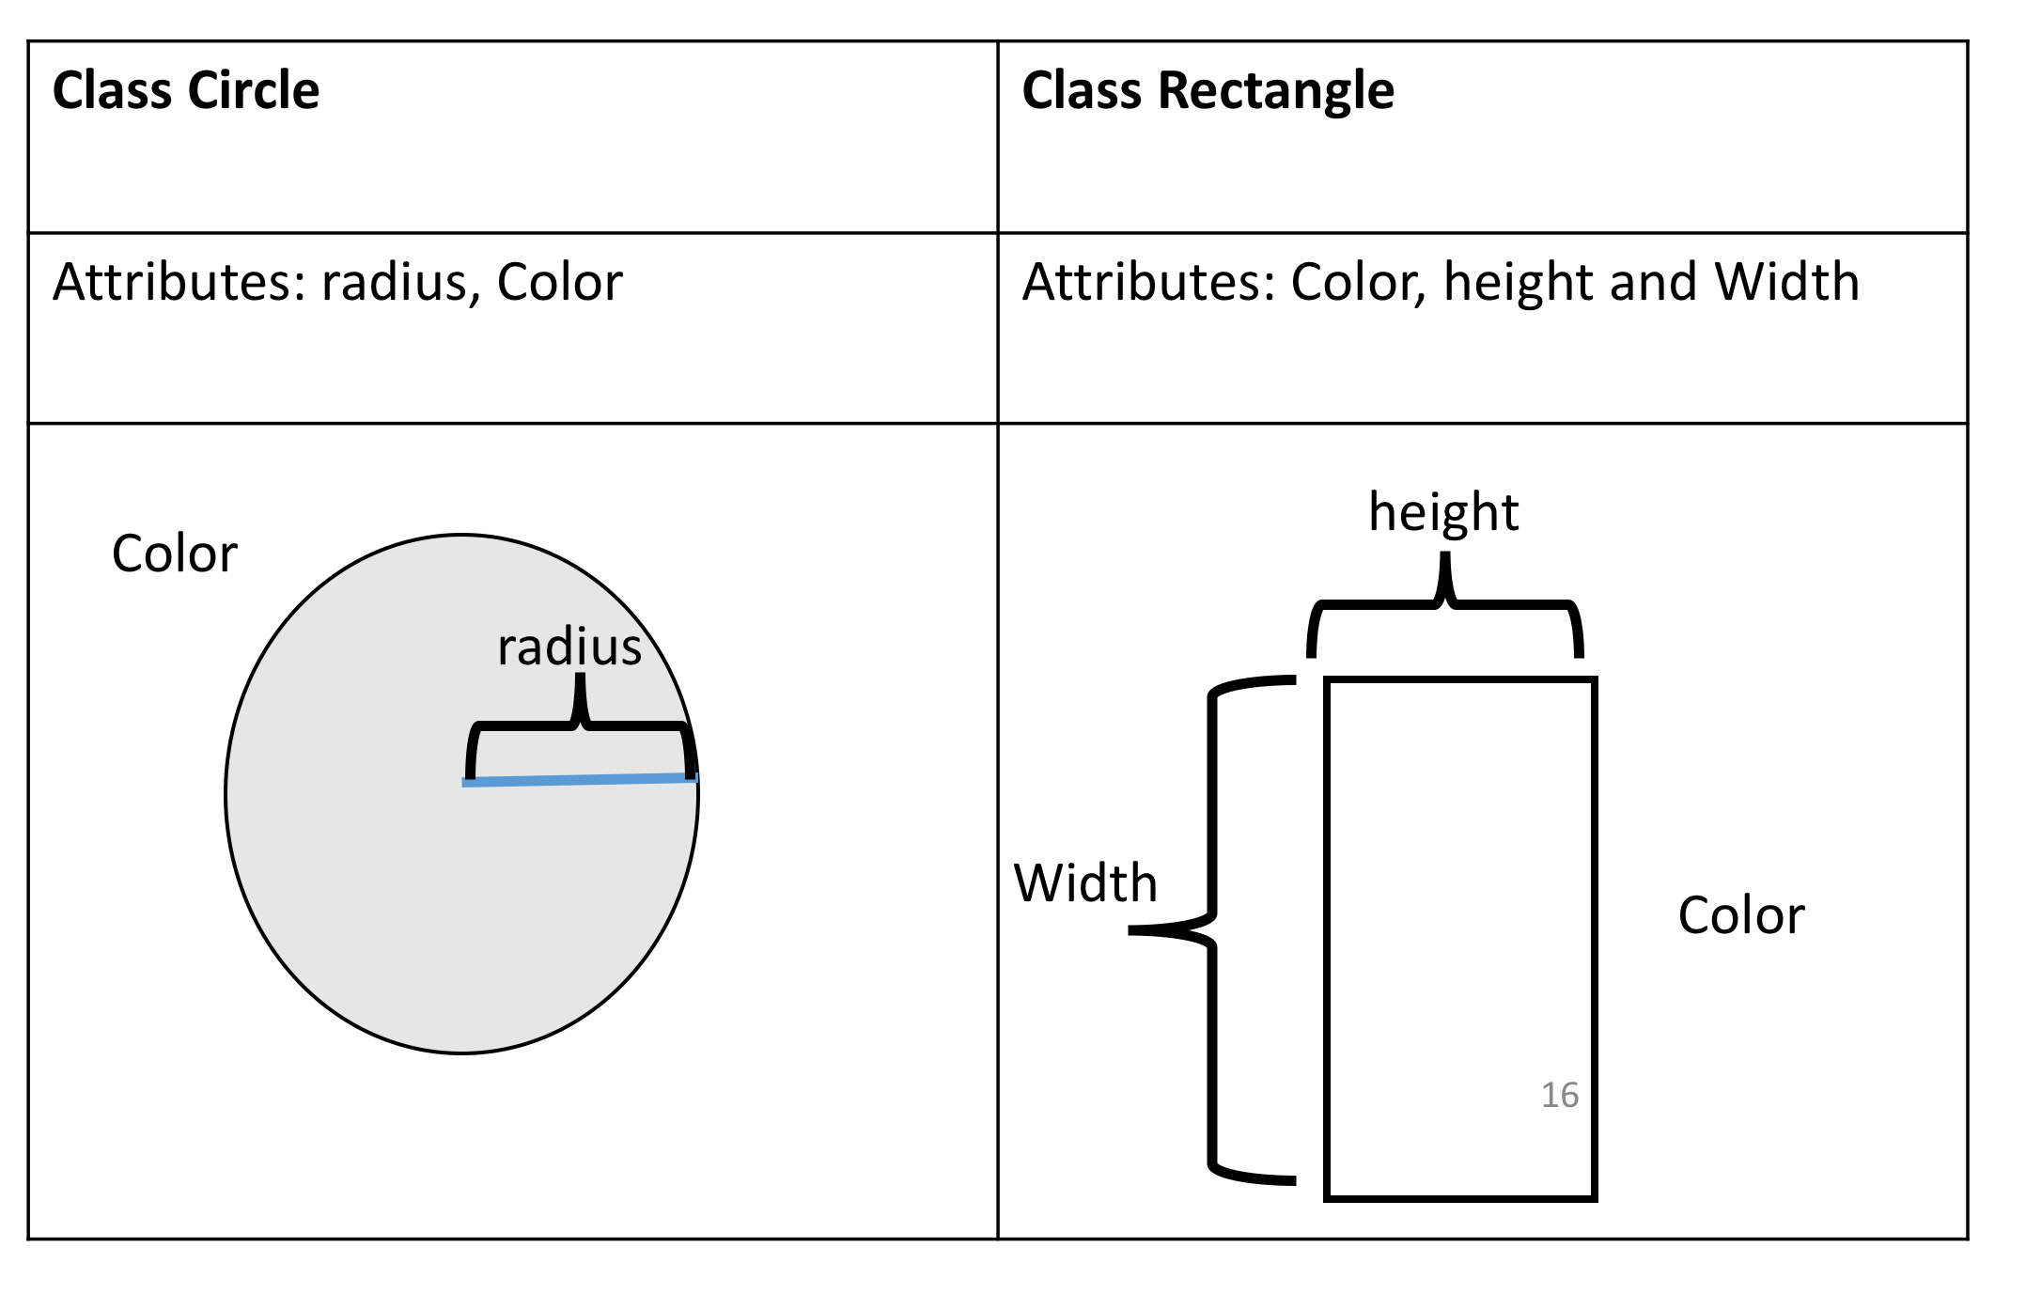

**Instances of a Class: Objects and Attributes**

An instance of an object is the realisation of a class, and in Figure 2 we see three instances of the class circle. We give each object a name: red circle, yellow circle, and green circle. Each object has different attributes, so let's focus on the color attribute for each object.

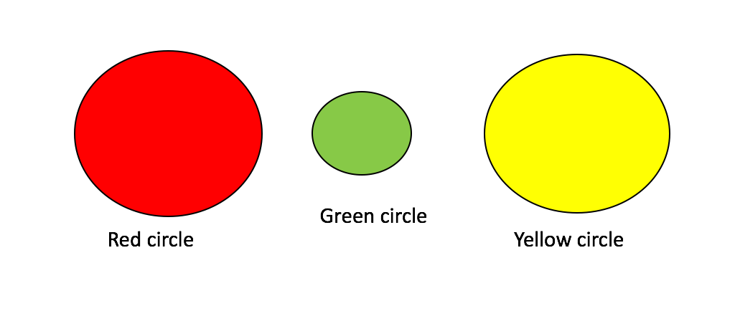

The colour attribute for the red Circle is the colour red, for the green Circle object the colour attribute is green, and for the yellow Circle the colour attribute is yellow.

**Methods**

Methods give you a way to change or interact with the object; they are functions that interact with objects. For example, let’s say we would like to increase the radius of a circle by a specified amount. We can create a method called **add_radius(r)** that increases the radius by **r**. This is shown in figure 3, where after applying the method to the "orange circle object", the radius of the object increases accordingly. The “dot” notation means to apply the method to the object, which is essentially applying a function to the information in the object.

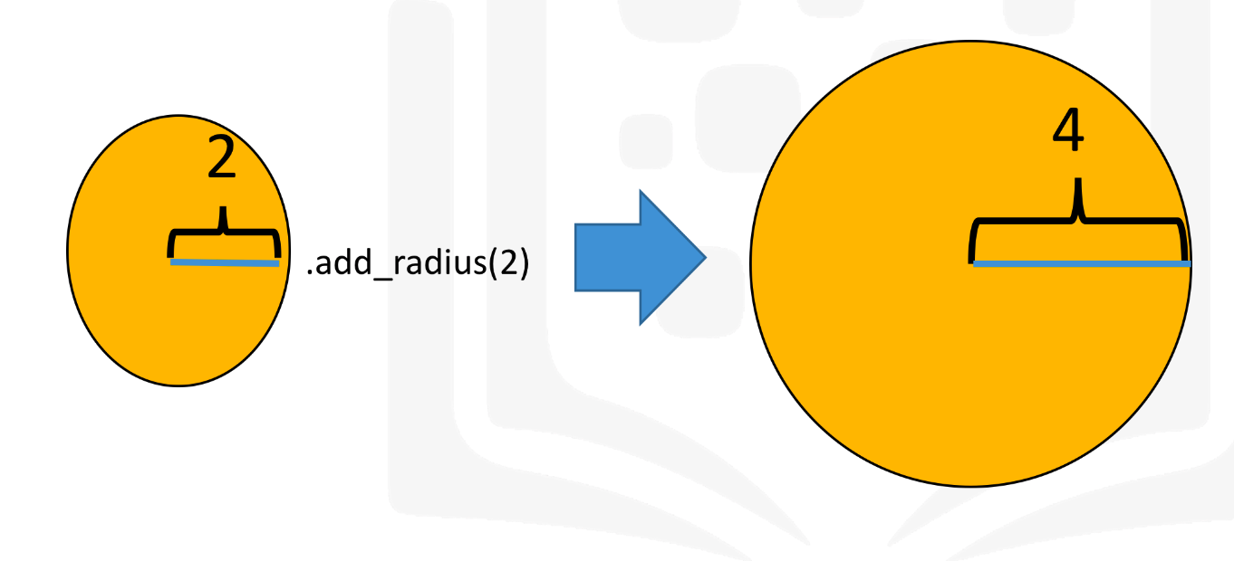

**Creating a Class**

Import a library to draw the objects:

**import matplotlib.pyplot as plt**

**%matplotlib inline**

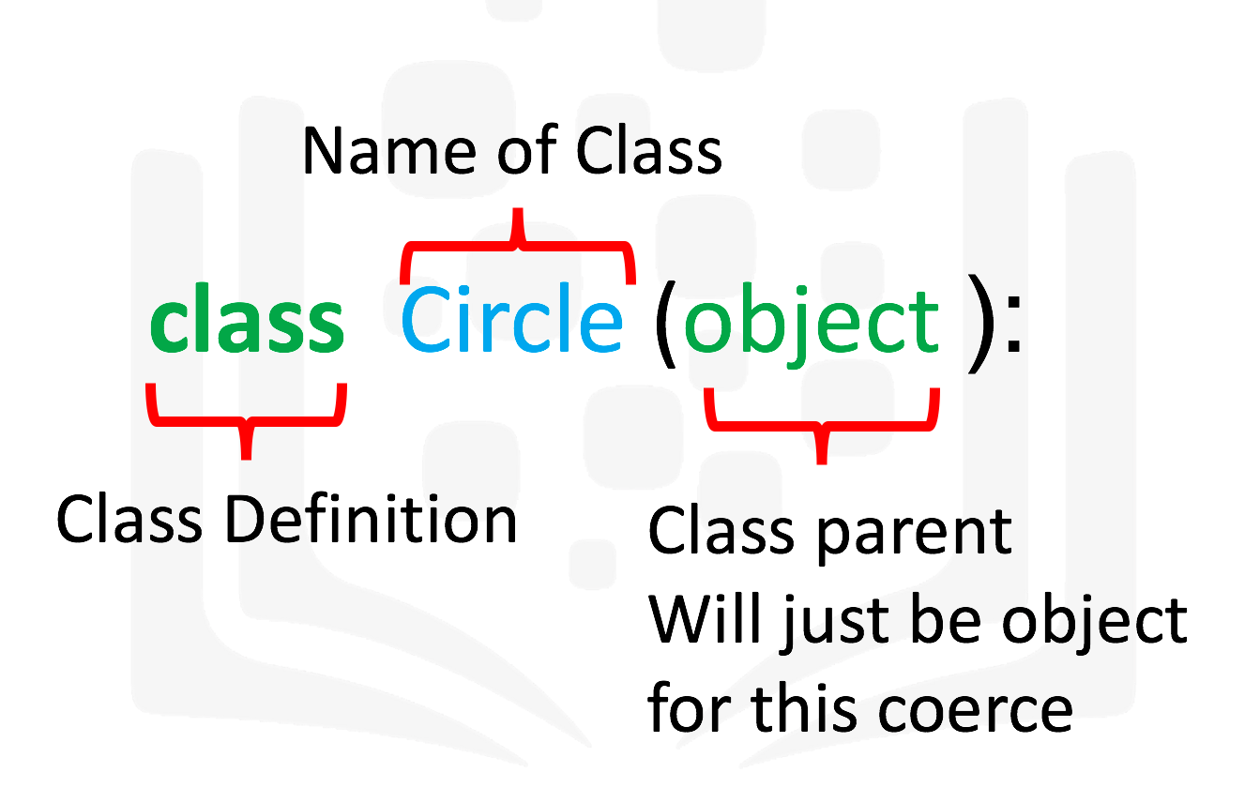

The next step is a special method called a constructor __init__, which is used to initialize the object. The inputs are data attributes. The term self contains all the attributes in the set. For example the self.color gives the value of the attribute color and self.radius will give you the radius of the object. We also have the method add_radius() with the parameter r, the method adds the value of r to the attribute radius. To access the radius we use the syntax self.radius.

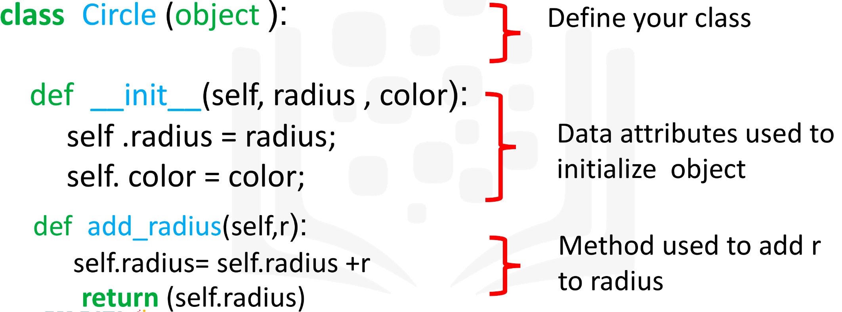

# Create a class Circle

**class Circle(object):**

**# Constructor**

**def __init__(self, radius=3, color='blue'):**

**self.radius = radius**

**self.color = color**

**# Method**

**def add_radius(self, r):**

**self.radius = self.radius + r**

**return(self.radius)**

**# Method**

**def drawCircle(self):**

**plt.gca().add_patch(plt.Circle((0, 0), radius=self.radius, fc=self.color))**

**plt.axis('scaled')**

**plt.show()**

Create a red circle:

**RedCircle = Circle(10, 'red')**

We can use the dir command to get a list of the object's methods. Many of them are default Python methods.

**dir(RedCircle)**

['__class__',

'__delattr__',

'__dict__',

'__dir__',

'__doc__',

'__eq__',

'__format__',

'__ge__',

'__getattribute__',

'__gt__',

'__hash__',

'__init__',

'__init_subclass__',

'__le__',

'__lt__',

'__module__',

'__ne__',

'__new__',

'__reduce__',

'__reduce_ex__',

'__repr__',

'__setattr__',

'__sizeof__',

'__str__',

'__subclasshook__',

'__weakref__',

'add_radius',

'color',

'drawCircle',

'radius']

Print the object attribute radius:

**RedCircle.radius**

10

Color:

**RedCircle.color**

‘red’

Change the attribute radius:

**RedCircle.radius = 1**

**RedCircle.radius**

1

Draw the object using the method drawCircle():

**RedCircle.drawCircle()**

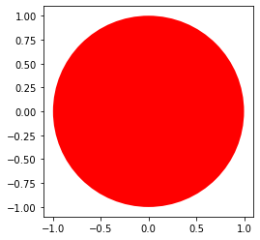

Increase the radius:

**RedCircle.add_radius(32)**

Define a rectangle class:

**class Rectangle(object):**

**# Constructor**

**def __init__(self, width=2, height=3, color='r'):**

**self.height = height**

**self.width = width**

**self.color = color**

**# Method**

**def drawRectangle(self):**

**plt.gca().add_patch(plt.Rectangle((0, 0), self.width, self.height ,fc=self.color))**

**plt.axis('scaled')**

**plt.show()**

Define and print a rectangle:

**ExRec = Rectangle(68, 34, 'brown')**

**ExRec.drawRectangle()**

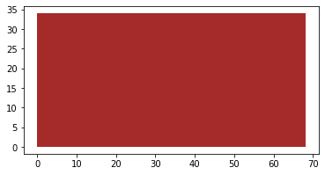

Get the attribute:

**print(ExRec.height)**

**print(ExRec.width)**

**print(ExRec.color)**

34

68

brown

#### Text Analysis

You have been recruited by your friend, a linguistics enthusiast, to create a utility tool that can perform analysis on a given piece of text. Complete the class 'analysedText' with the following methods -

* Constructor - Takes argument 'text',makes it lower case and removes all punctuation. Assume only the following punctuation is used - period (.), exclamation mark (!), comma (,) and question mark (?). Store the argument in "fmtText"
* freqAll - returns a dictionary of all unique words in the text along with the number of their occurences.
* freqOf - returns the frequency of the word passed in argument.

The skeleton code has been given to you. Docstrings can be ignored for the purpose of the exercise.   
*Hint: Some useful functions are replace(), lower(), split(), count()*

**class analysedText(object):**

**def __init__ (self, text):**

**# remove punctuation**

**formattedText = text.replace('.','').replace('!','').replace('?','').replace(',','')**

**# make text lowercase**

**formattedText = formattedText.lower()**

**self.fmtText = formattedText**

**def freqAll(self):**

**# split text into words**

**wordList = self.fmtText.split(' ')**

**# Create dictionary**

**freqMap = {}**

**for word in set(wordList): # use set to remove duplicates in list**

**freqMap[word] = wordList.count(word)**

**return freqMap**

**def freqOf(self,word):**

**# get frequency map**

**freqDict = self.freqAll()**

**if word in freqDict:**

**return freqDict[word]**

**else:**

**return 0**

Check your progress:

**import sys**

**sampleMap = {'eirmod': 1,'sed': 1, 'amet': 2, 'diam': 5, 'consetetur': 1, 'labore': 1, 'tempor': 1, 'dolor': 1, 'magna': 2, 'et': 3, 'nonumy': 1, 'ipsum': 1, 'lorem': 2}**

**def testMsg(passed):**

**if passed:**

**return 'Test Passed'**

**else :**

**return 'Test Failed'**

**print("Constructor: ")**

**try:**

**samplePassage = analysedText("Lorem ipsum dolor! diam amet, consetetur Lorem magna. sed diam nonumy eirmod tempor. diam et labore? et diam magna. et diam amet.")**

**print(testMsg(samplePassage.fmtText == "lorem ipsum dolor diam amet consetetur lorem magna sed diam nonumy eirmod tempor diam et labore et diam magna et diam amet"))**

**except:**

**print("Error detected. Recheck your function " )**

**print("freqAll: ")**

**try:**

**wordMap = samplePassage.freqAll()**

**print(testMsg(wordMap==sampleMap))**

**except:**

**print("Error detected. Recheck your function " )**

**print("freqOf: ")**

**try:**

**passed = True**

**for word in sampleMap:**

**if samplePassage.freqOf(word) != sampleMap[word]:**

**passed = False**

**break**

**print(testMsg(passed))**

**except:**

**print("Error detected. Recheck your function " )**

Constructor:

Test Passed

freqAll:

Test Passed

freqOf:

Test Passed

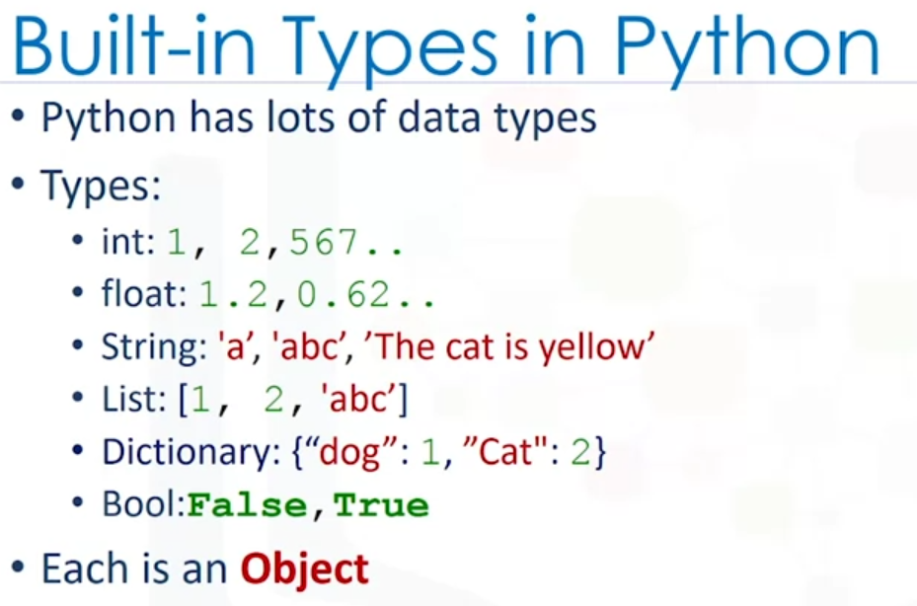

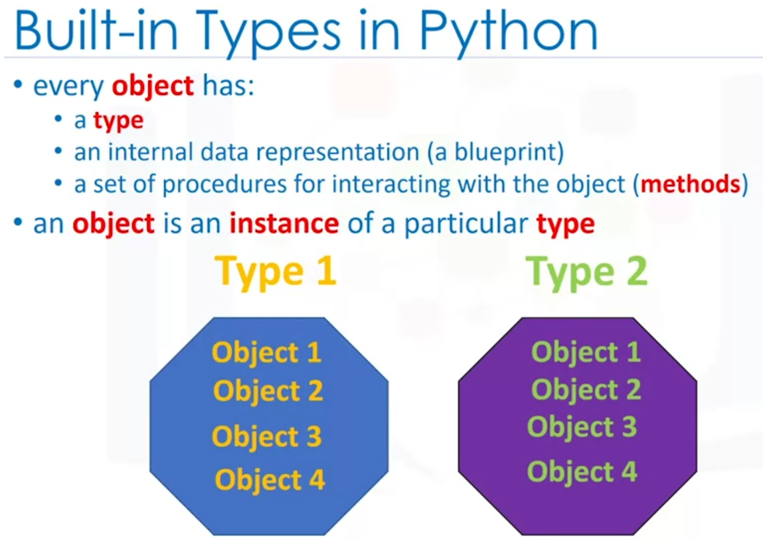

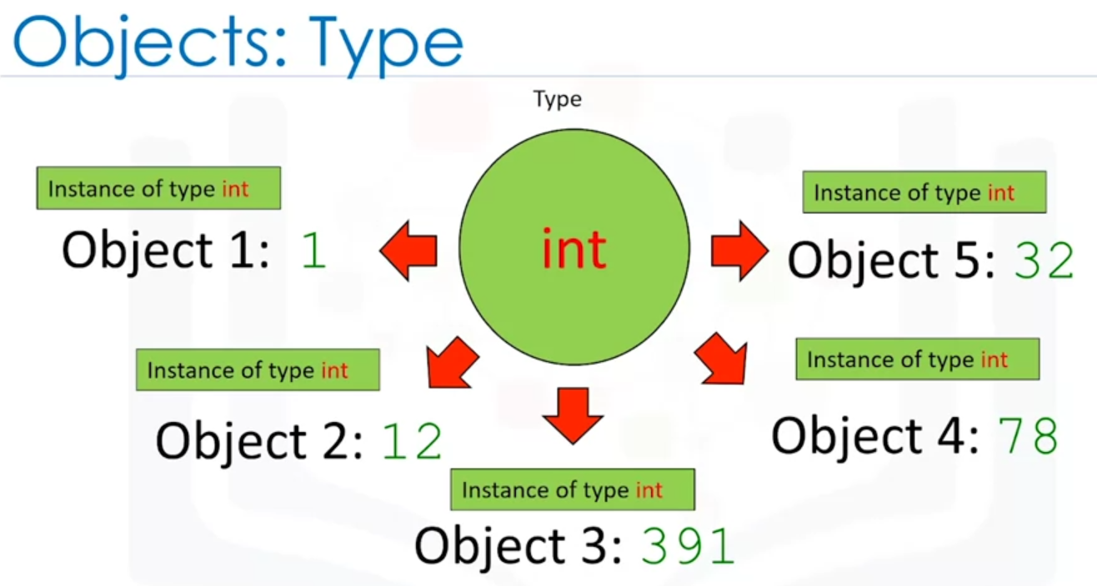

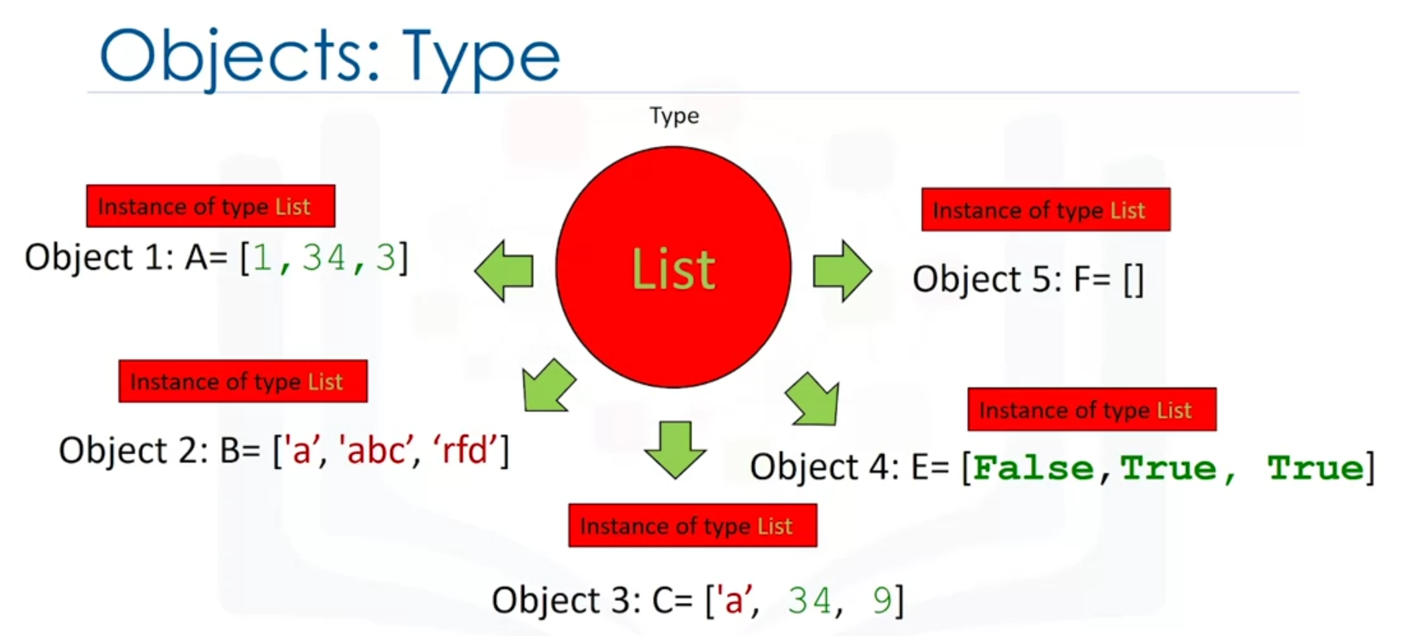

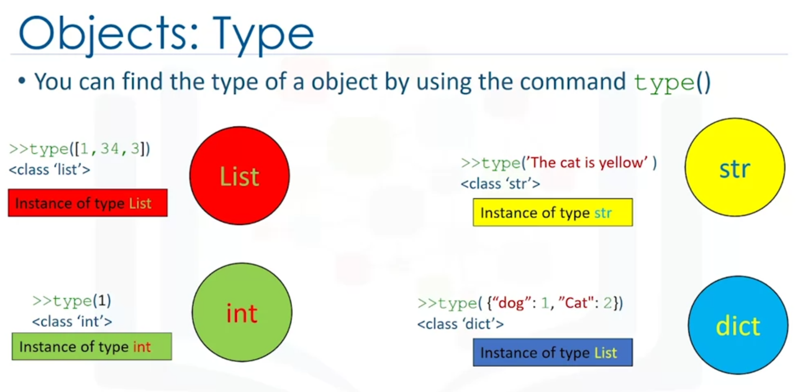

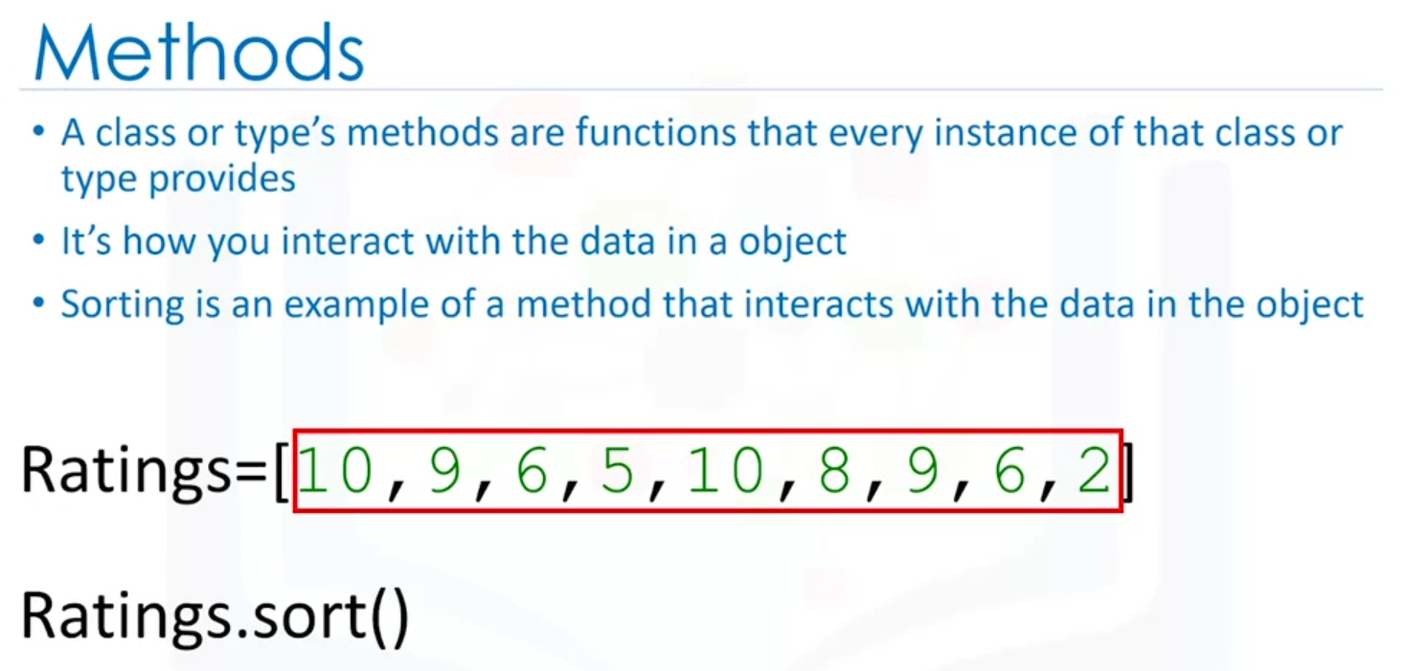

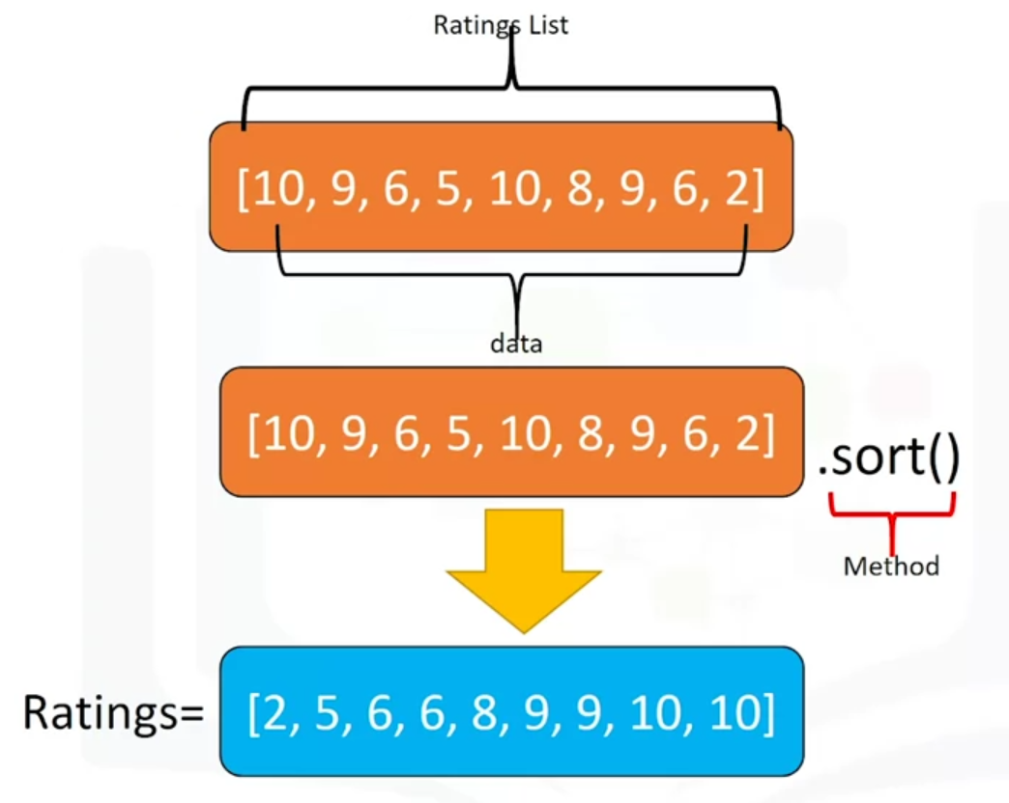

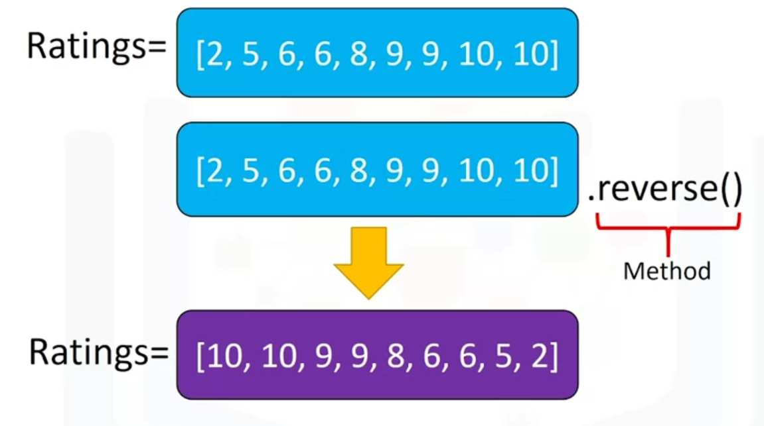

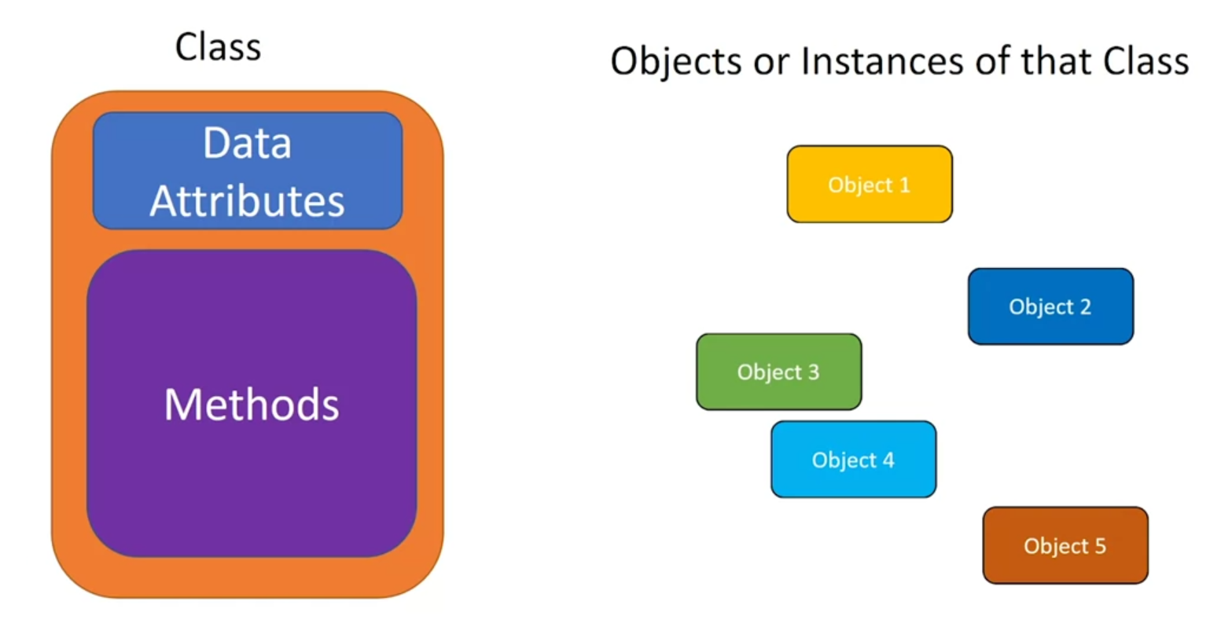

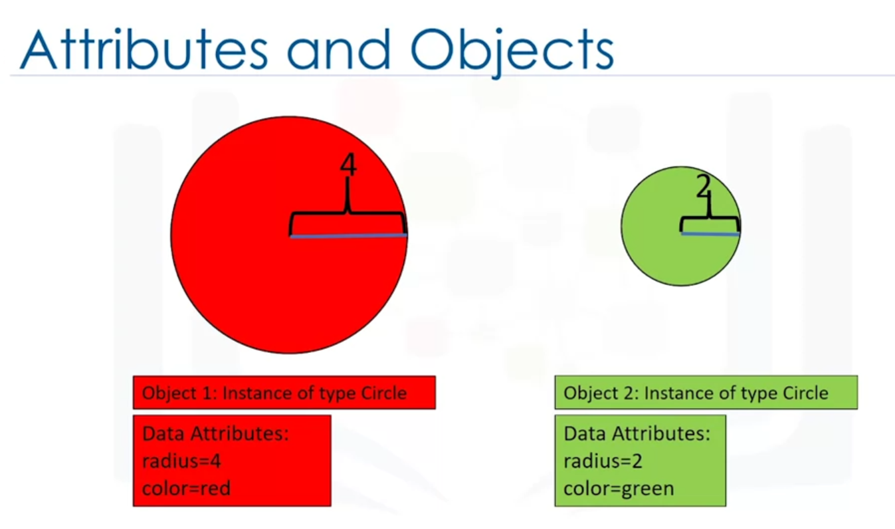

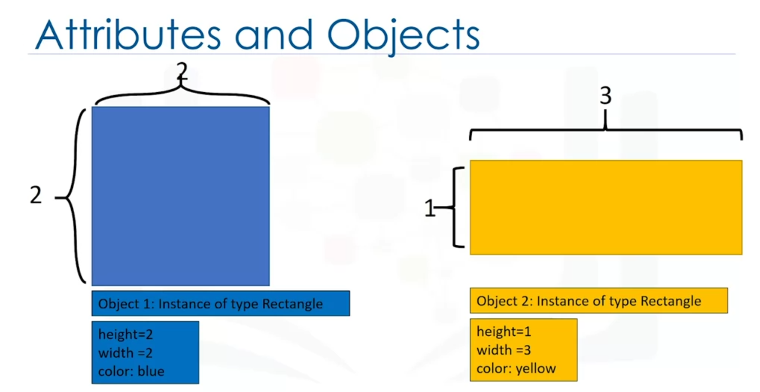

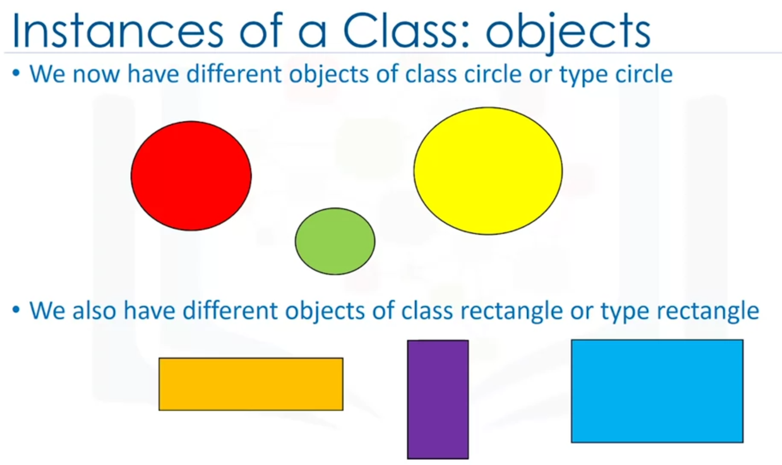

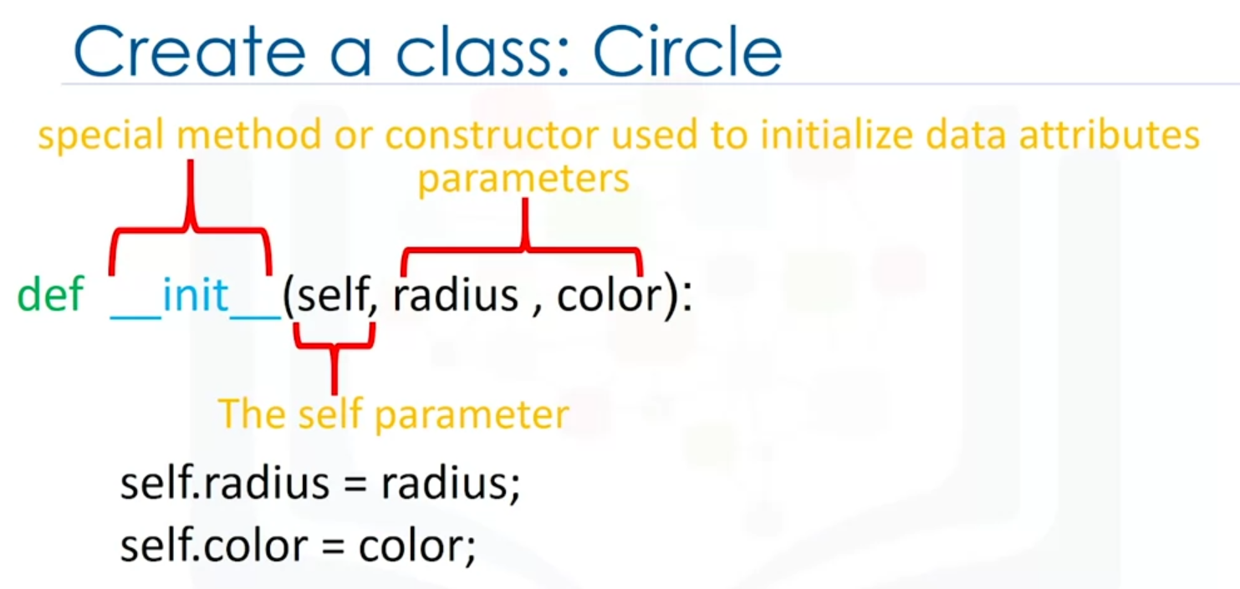

The self parameter refers to the newly created instance of the class.

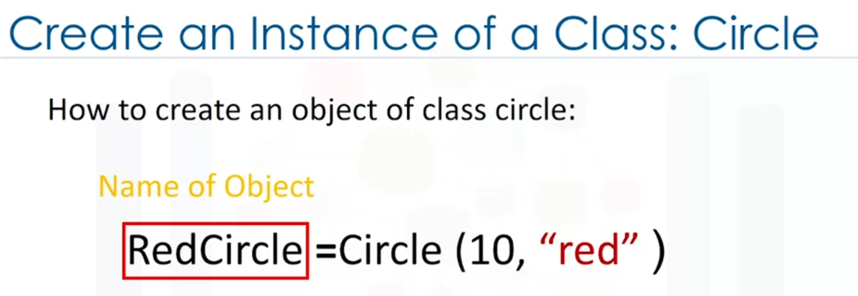

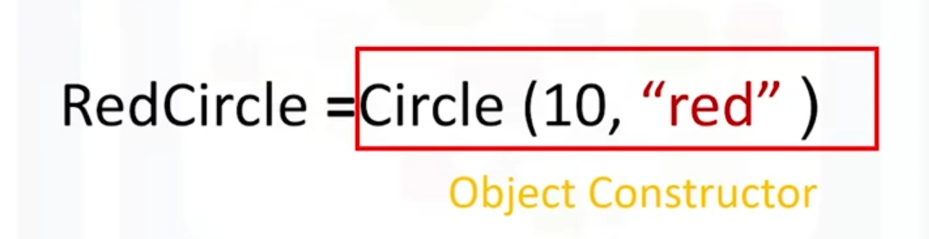

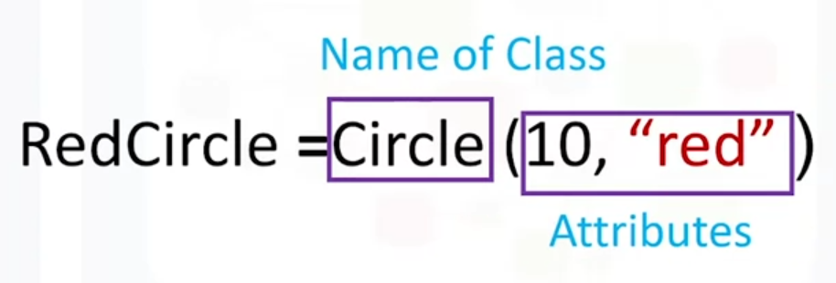

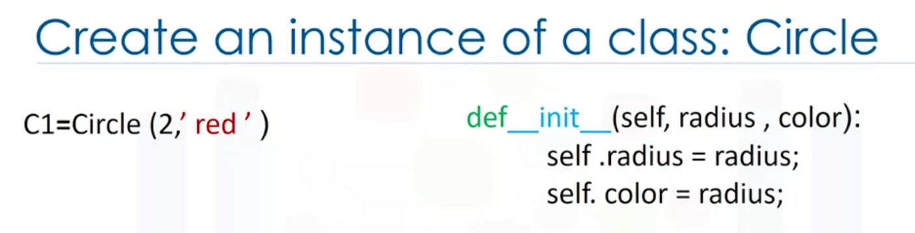

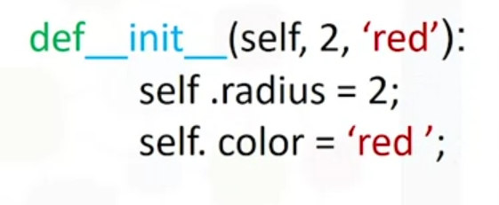

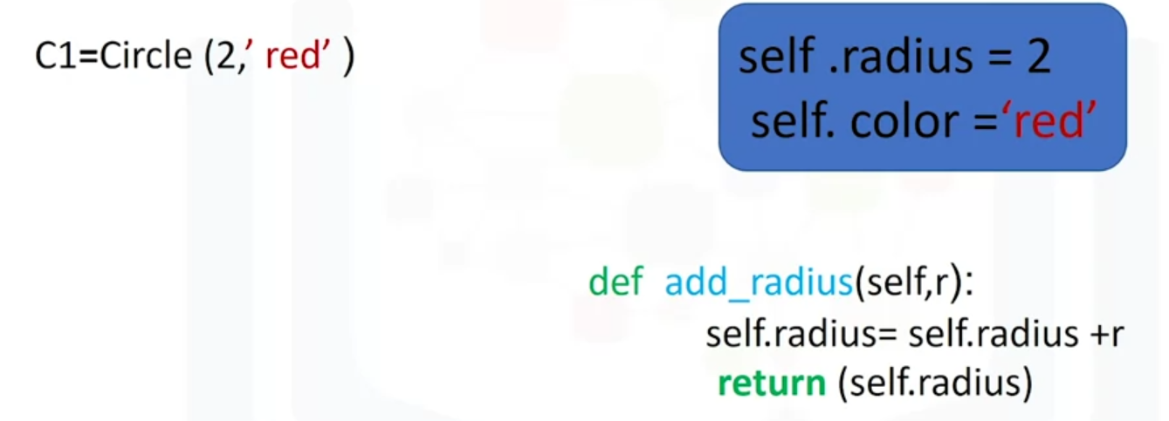

Я бы читал это так: self = рандомное название (в данном случае С1), radius, color.

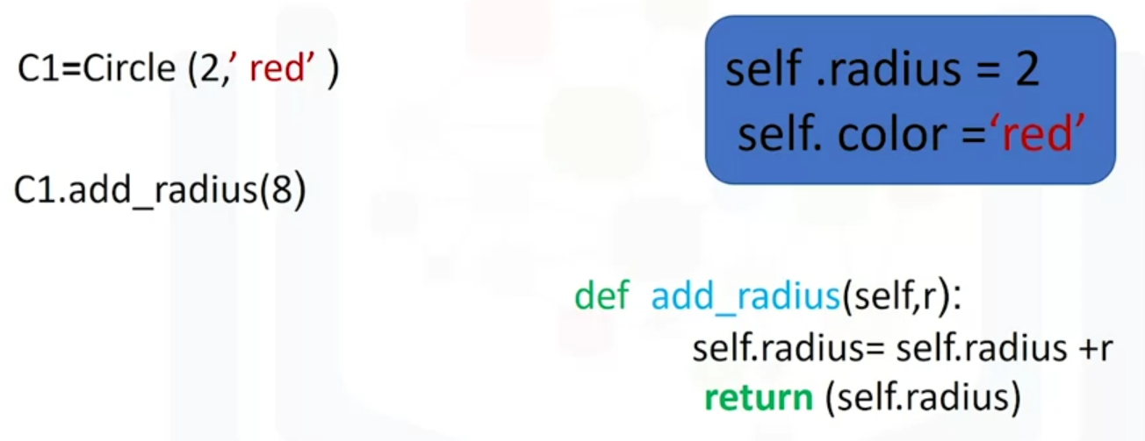

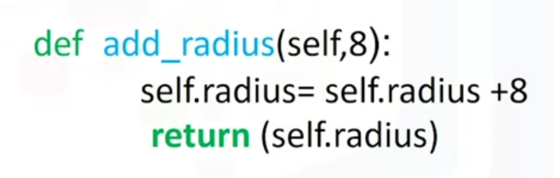

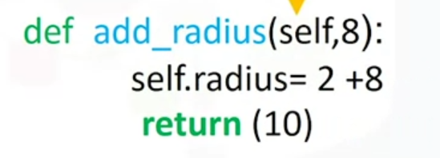

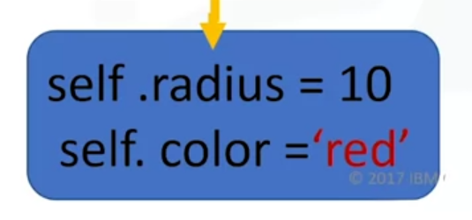

**Week 4**

**Reading Files with Open**

If we want to open a file we need to give a path to the file:

**File1 = open(‘/resources/data/Example2.txt’, ‘w’)**

**File1** file object

**Example2.txt** file name

**/resources/data/** directory

**‘w’** Mode (режим): **r** = reading, **w** = writing, **a** = appending

Get the name of the file (the result is the string that contains the name of the file) / get the mode:

**File1.name File1.mode**

‘/resources/data/Example2.txt’ ‘w’

Always close the file object using the method close():

**File1.close()**

An alternative to using File1.close(). The advantage is that it automatically closes the file object:

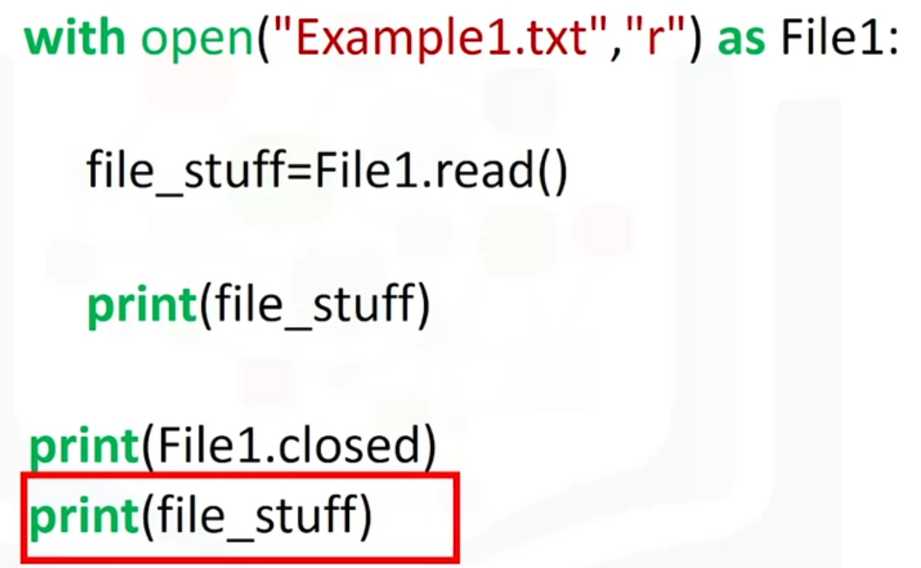

Print every element in the file in a list:

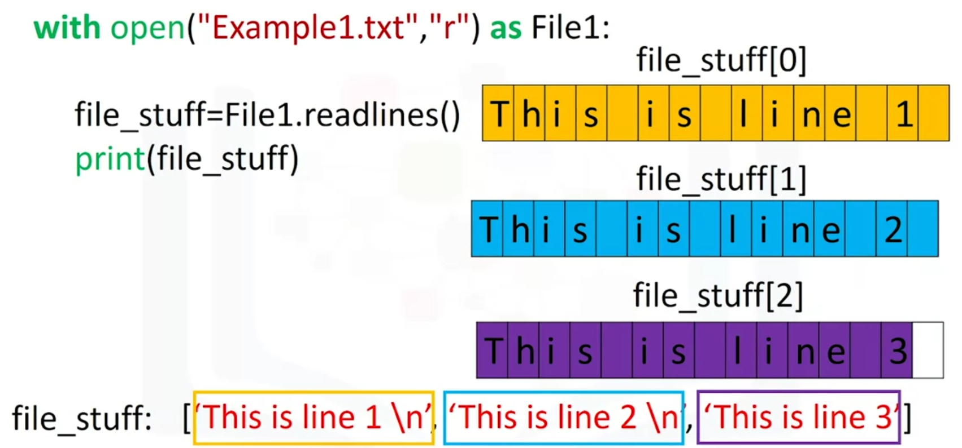

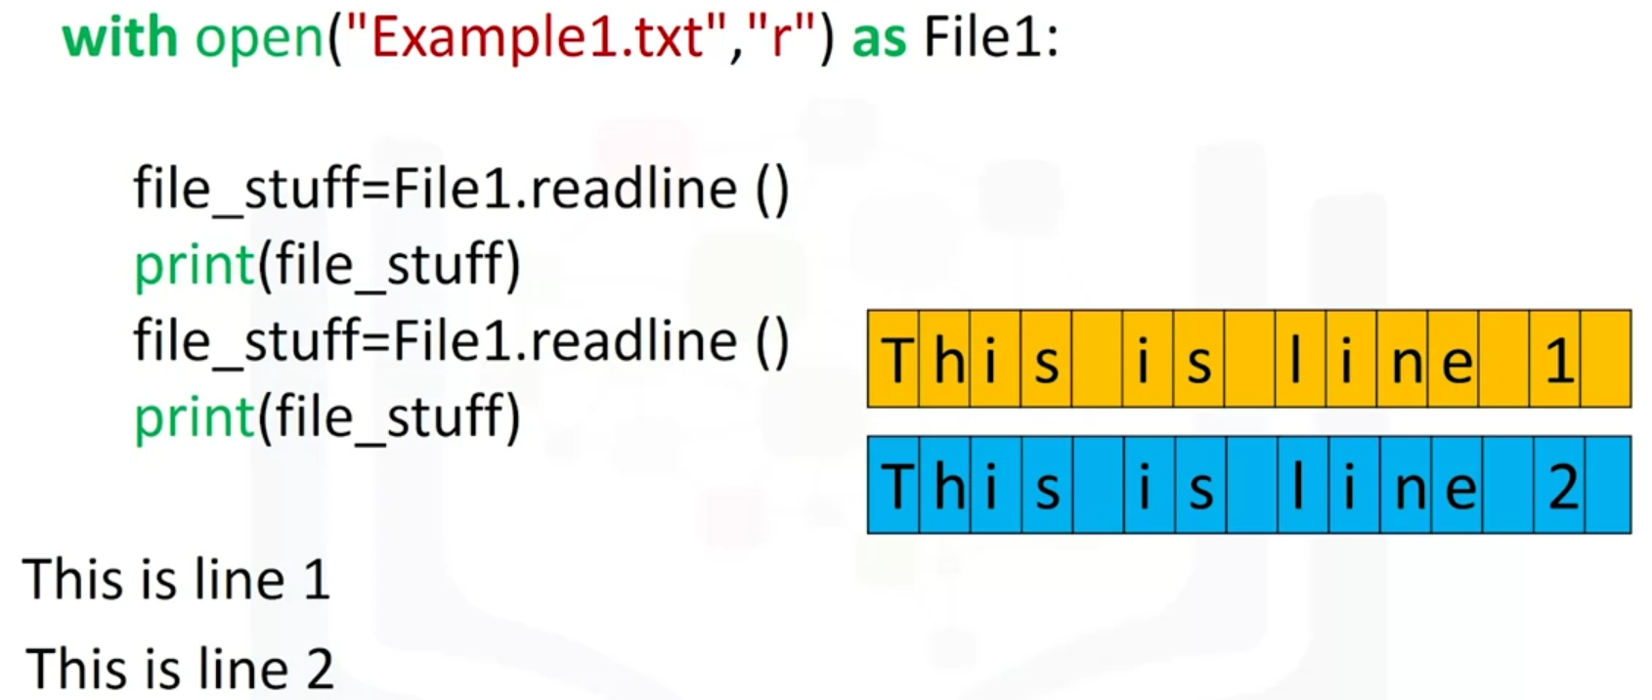

Use a loop to print each line:

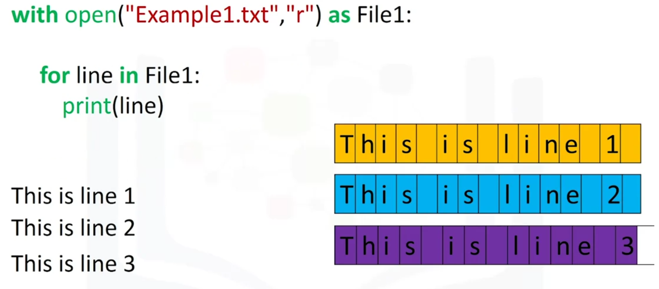

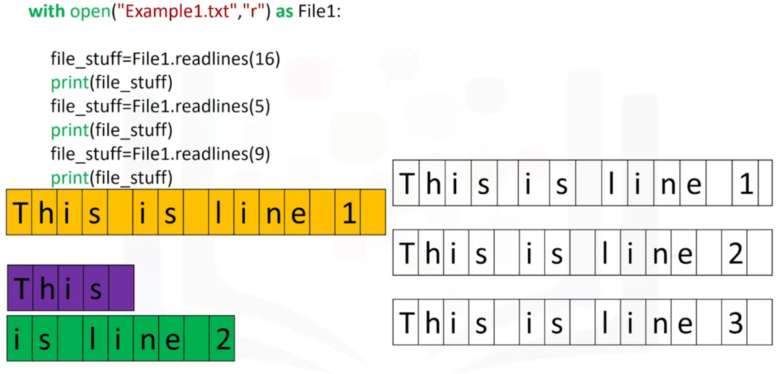

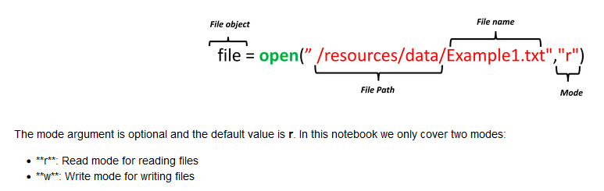

* ‘a’ append mode to add something to files

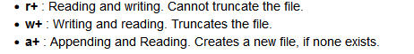

Open the file using *with*:

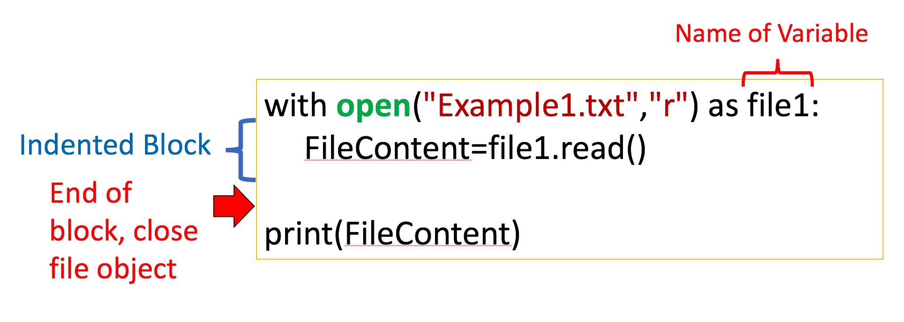

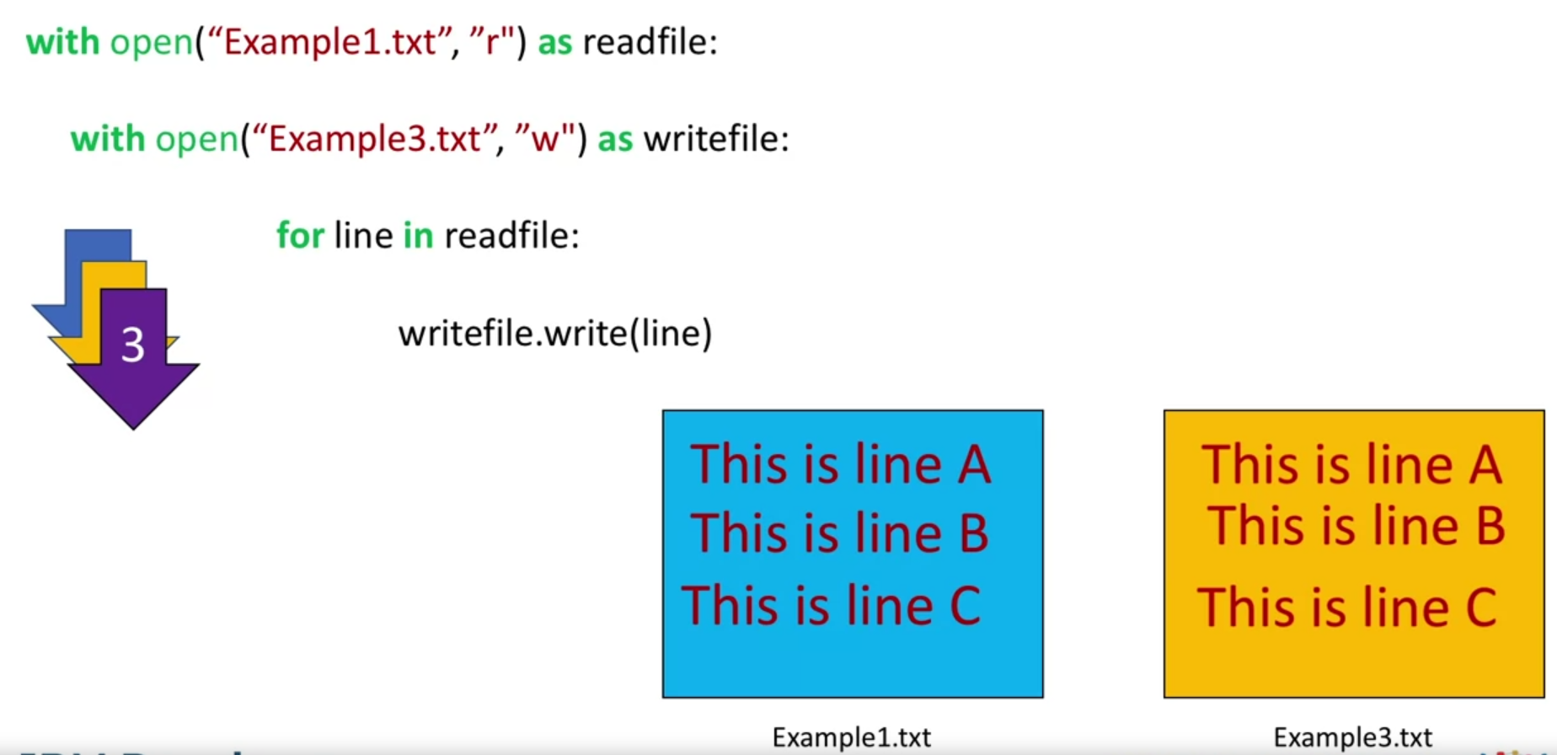

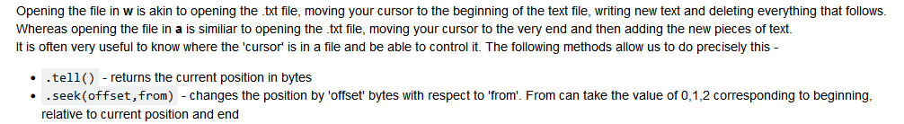



**Pandas**

Create a dataframe (table) out of a dictionary:

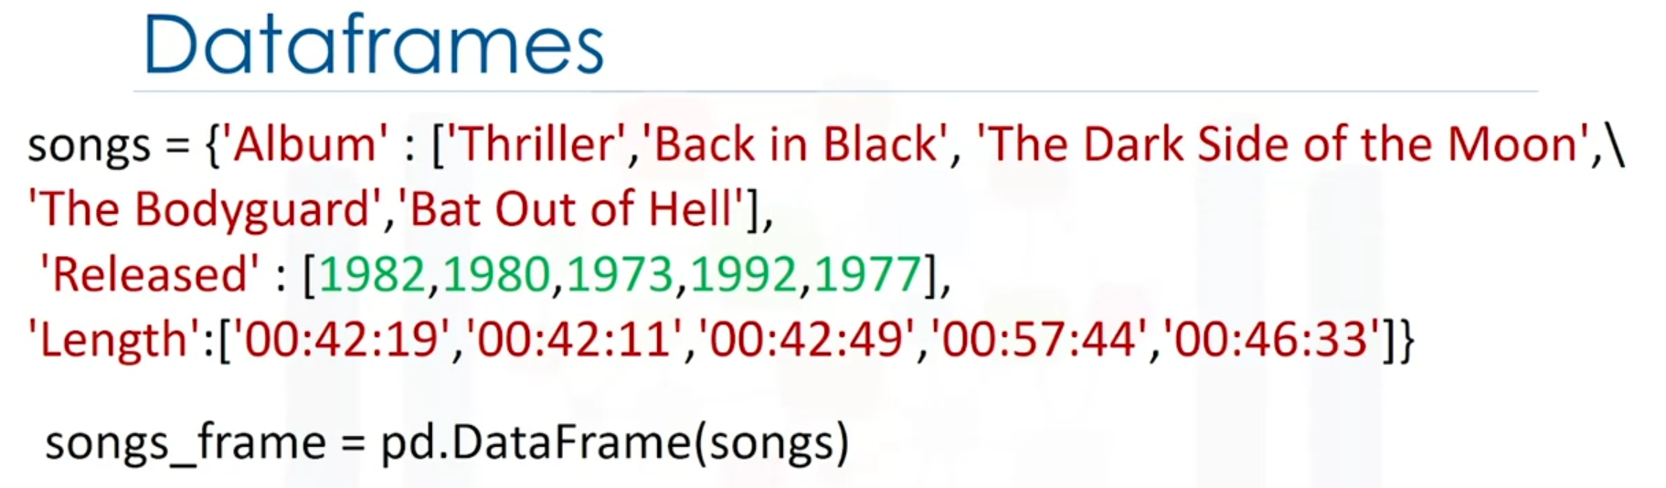

Select one column:

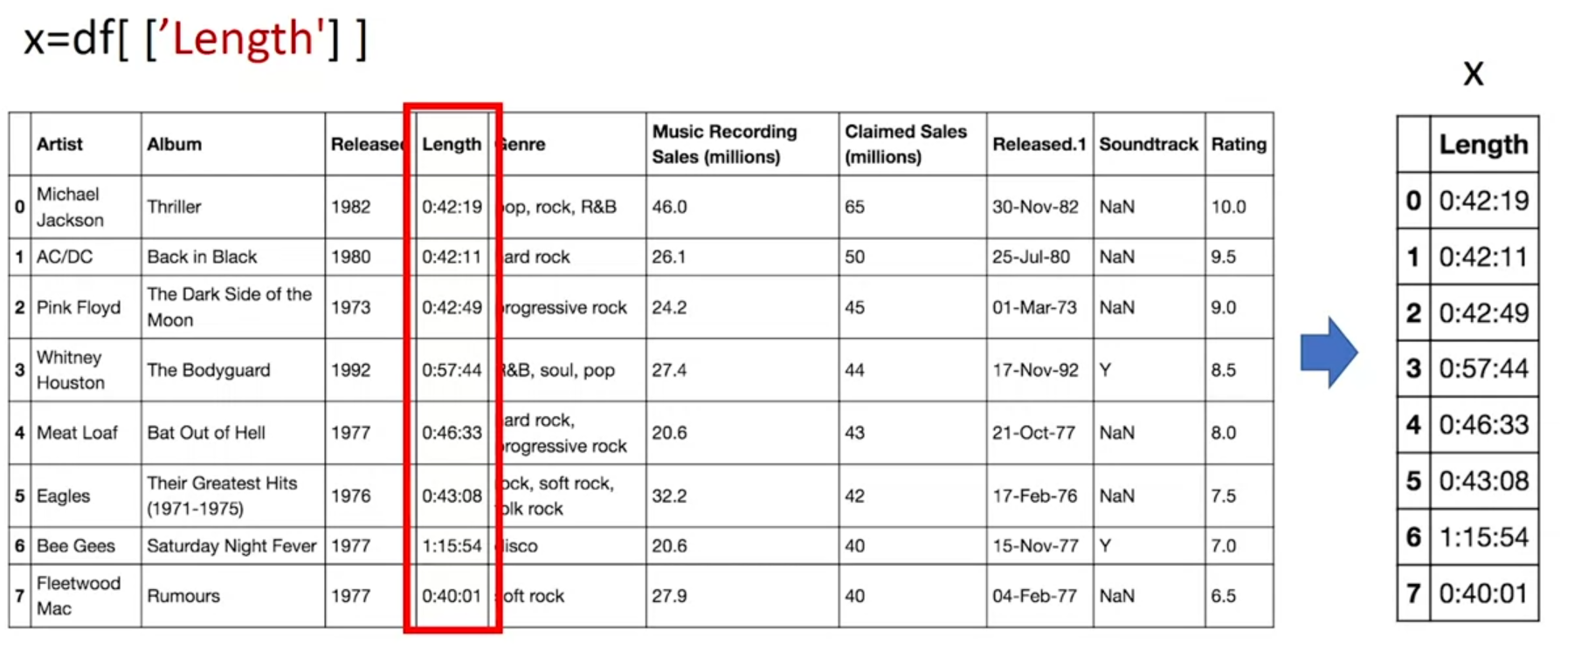

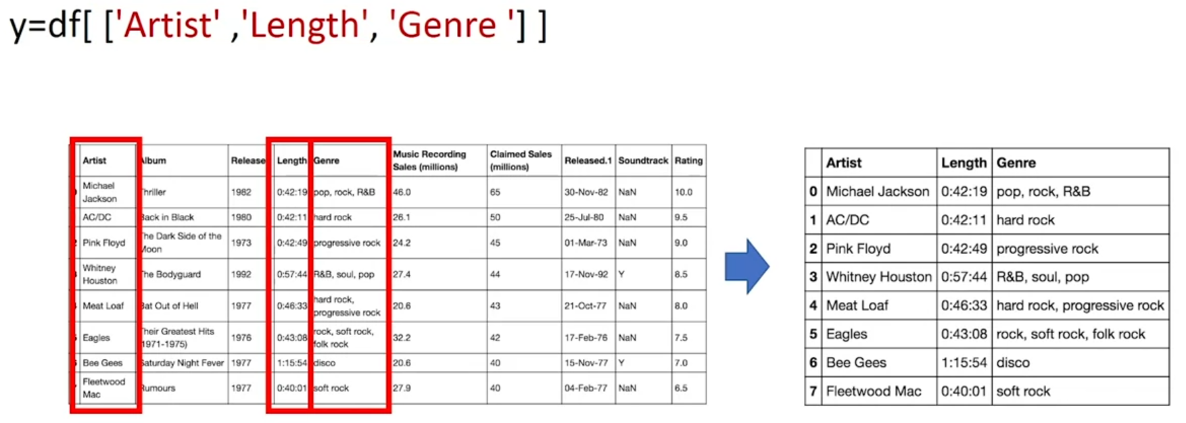

Show DISTINCT values (remove duplicates):  
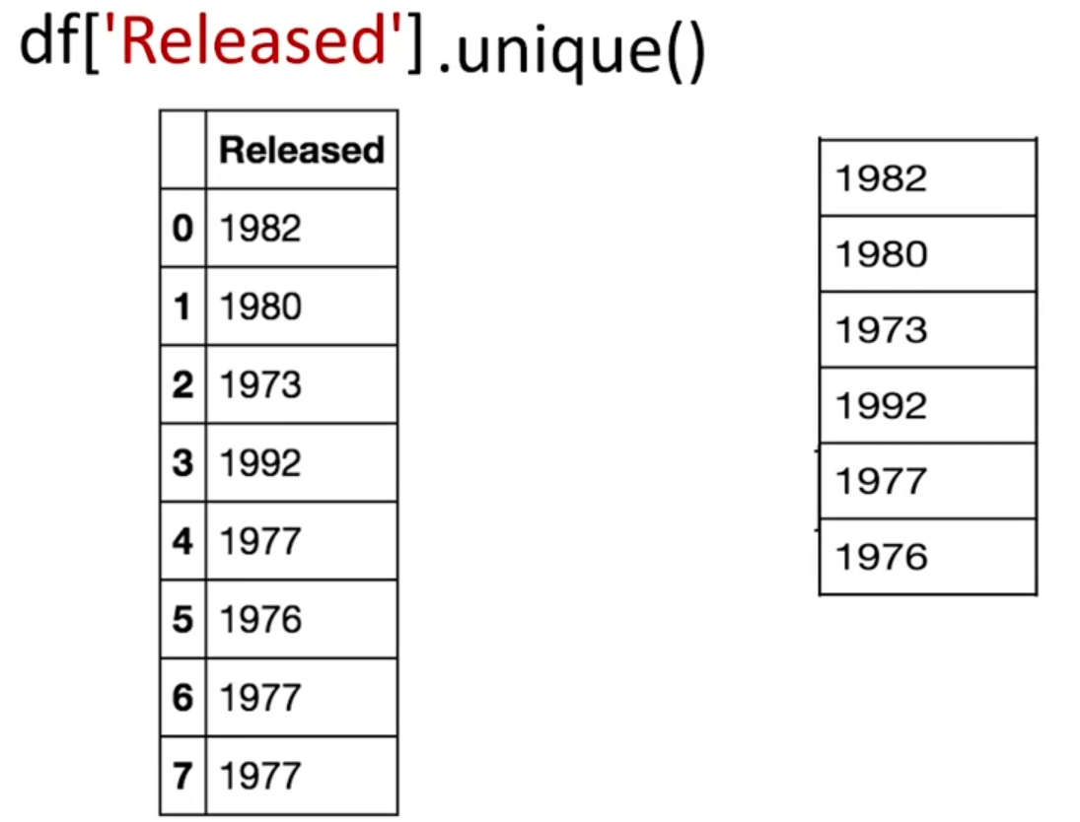

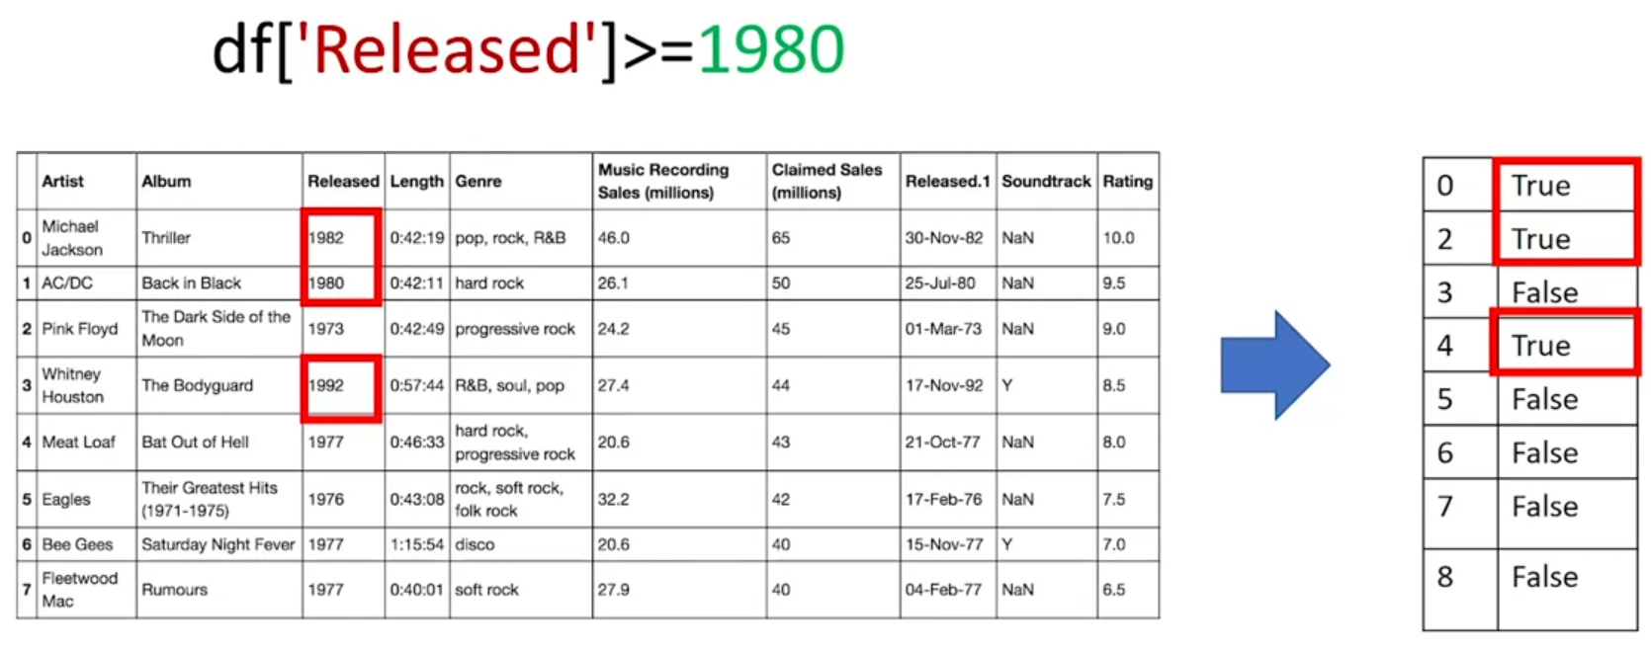

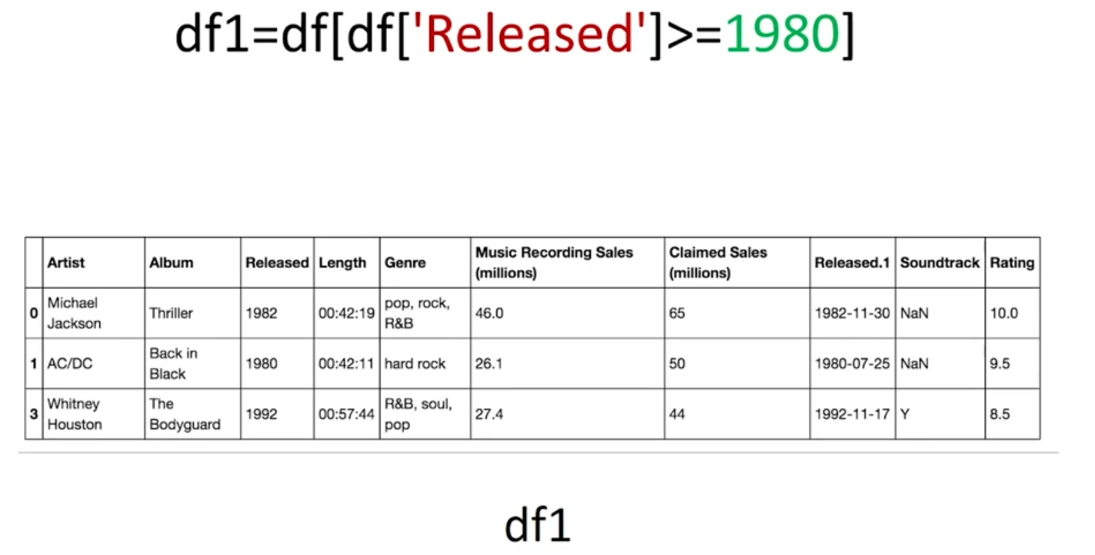

If you want to change the index (1, 2, 3, 4, 5 etc. of the table to e.g. a, b, c, d etc.):

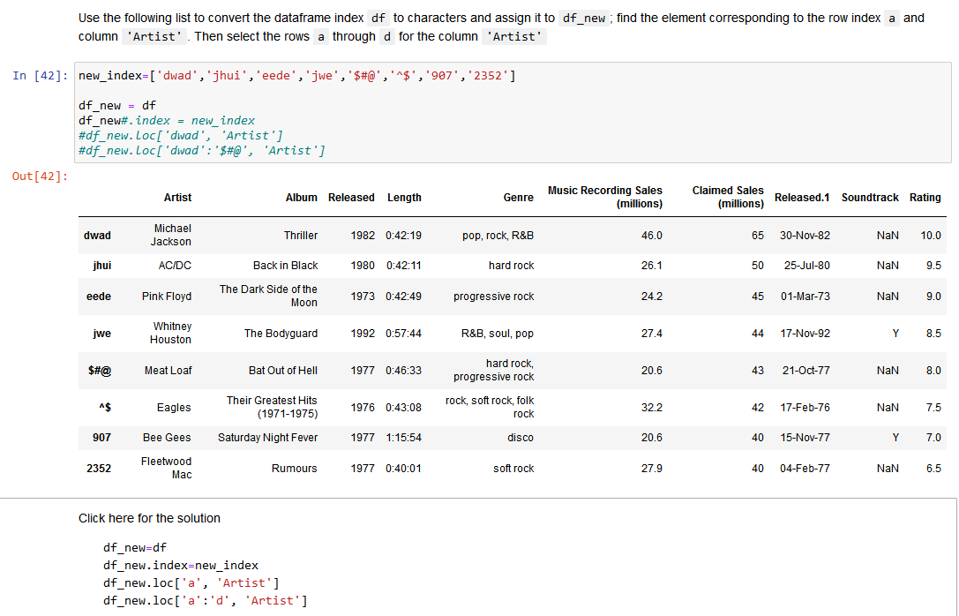

**Selecting data in a Dataframe**

**Pandas** is a popular library for data analysis built on top of the Python programming language. Pandas generally provide two data structures for manipulating data, They are:

* DataFrame
* Series

A **DataFrame** is a two-dimensional data structure, i.e., data is aligned in a tabular fashion in rows and columns.

* A Pandas DataFrame will be created by loading the datasets from existing storage.
* Storage can be SQL Database, CSV file, an Excel file, etc.
* It can also be created from the lists, dictionary, and from a list of dictionaries.

**Series** represents a one-dimensional array of indexed data. It has two main components :

1. An array of actual data.
2. An associated array of indexes or data labels.

The index is used to access individual data values. You can also get a column of a dataframe as a **Series**. You can think of a Pandas series as a 1-D dataframe.

iloc and loc functions:

**iloc[row_index, column_index]** = use numbers e.g. 0, 0

**loc[row_label, column_label]** = use name of the rows and columns, e.g. (if you have changed row numbers to something else) de2d2, ID

Set a column as an index (row numbers, first column):

**df2 = df**

**df2 = df2.set_index('ID')**

**df2**

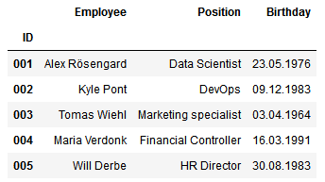

**Slicing**

If you want to select rows 0, 1, and 2 your code would look like this: df.iloc[0:3]. It means you are telling Python to start at index 0 and select rows 0, 1, 2 up to but not including 3.

Indexing by labels(i.e. using loc()) differs from indexing by integers (i.e. using iloc()). With loc(), both the start bound and the stop bound are inclusive. When using loc(), integers can be used, but the integers refer to the index label and not the position.

For example, using loc() and select 1:4 will get a different result than using iloc() to select rows 1:4.

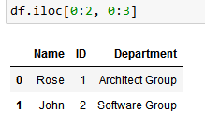

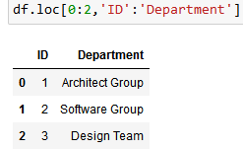

Loc takes the real values that are written in the table. That is why it is from 0 to 2 and from ID to Department.

**Numpy**

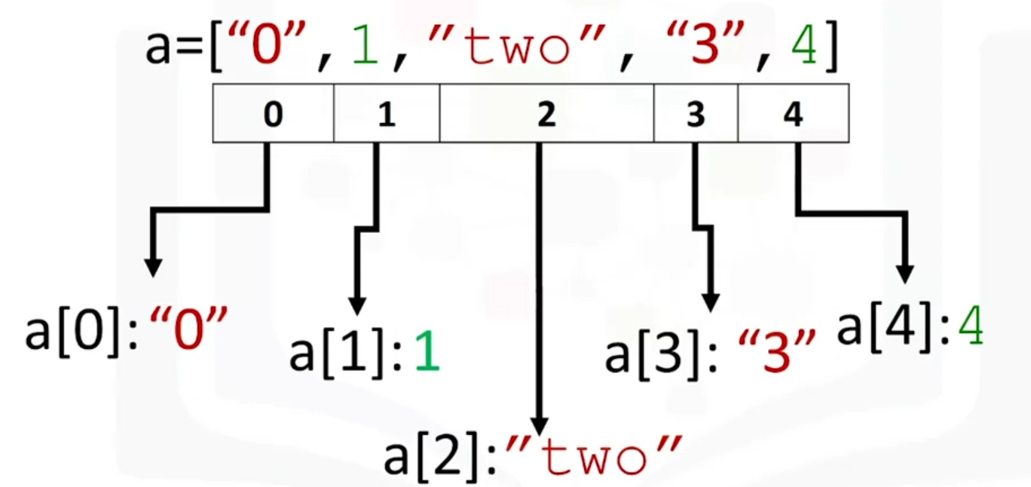

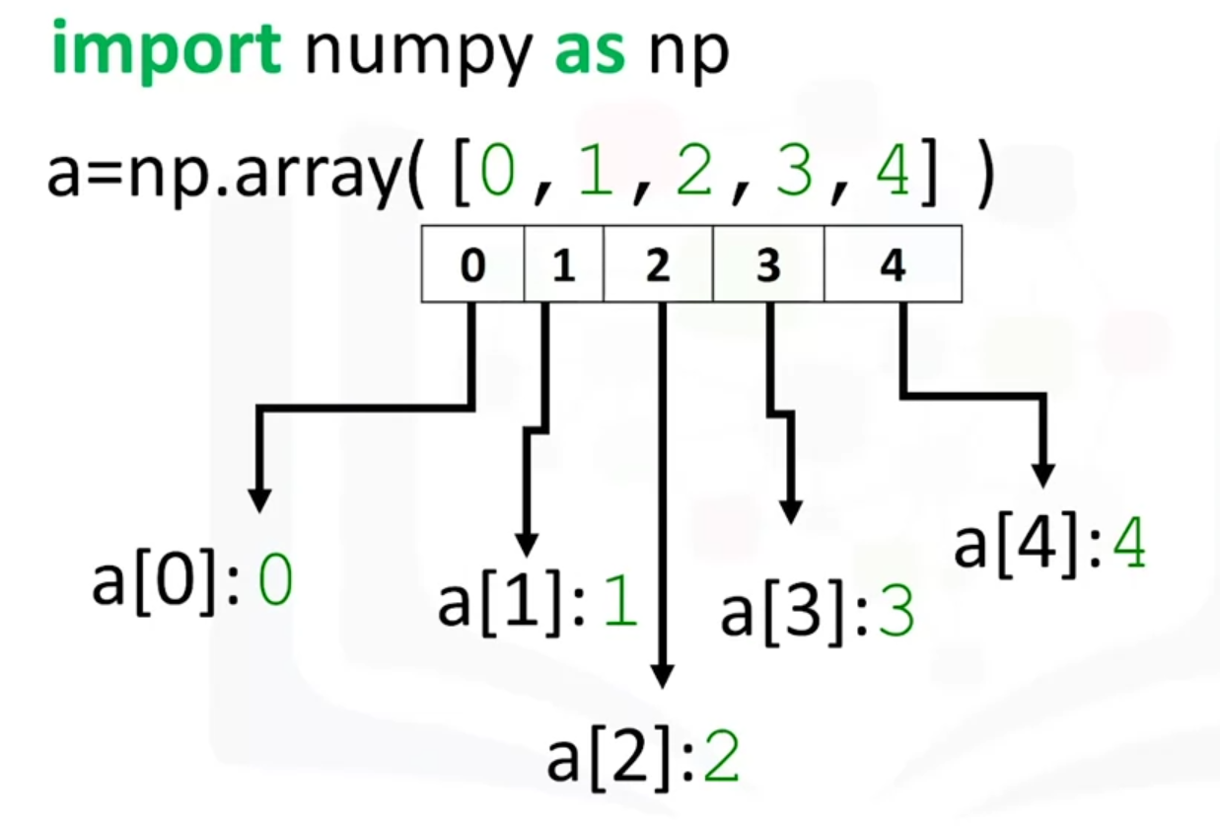

a.size

5

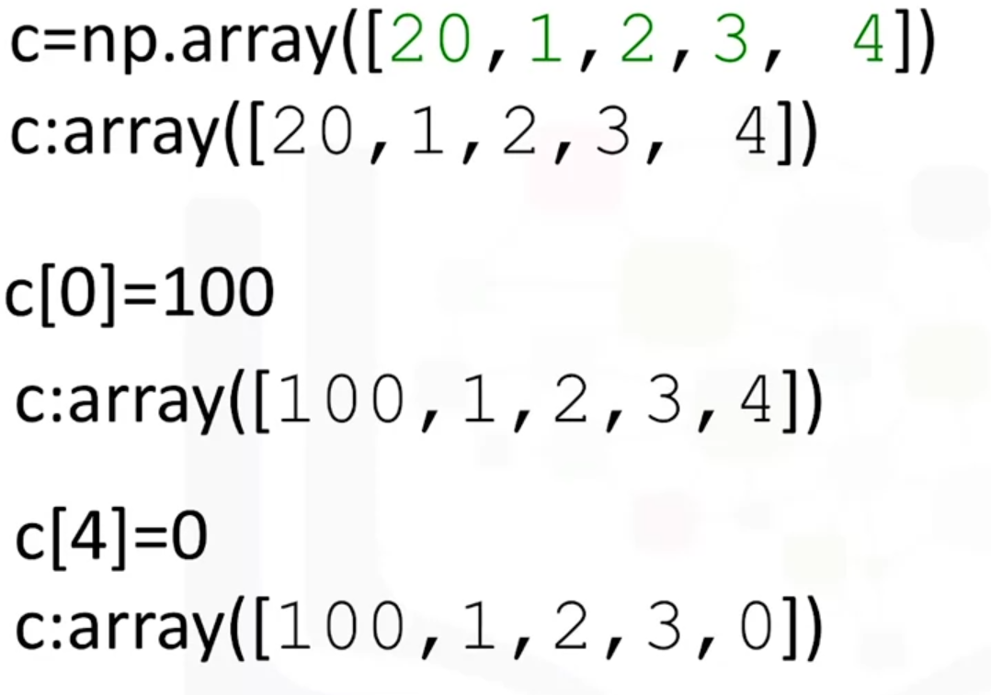

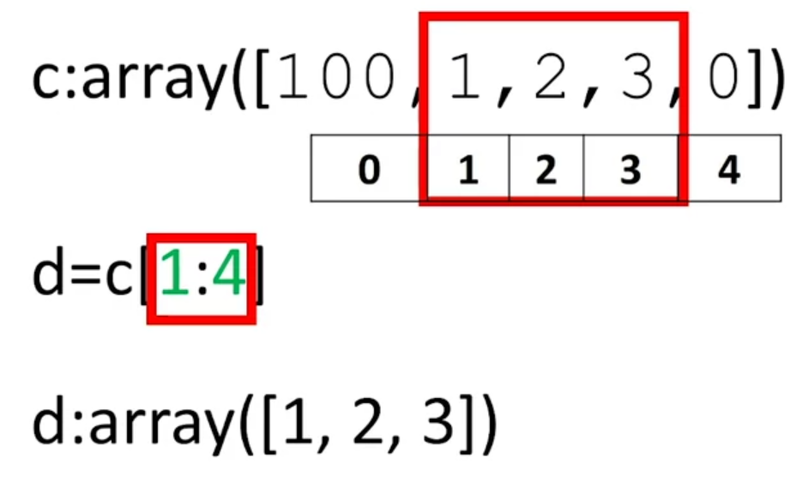

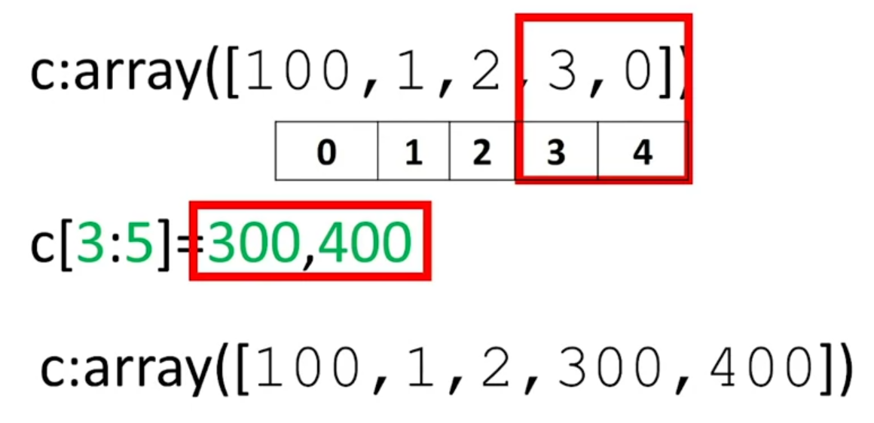

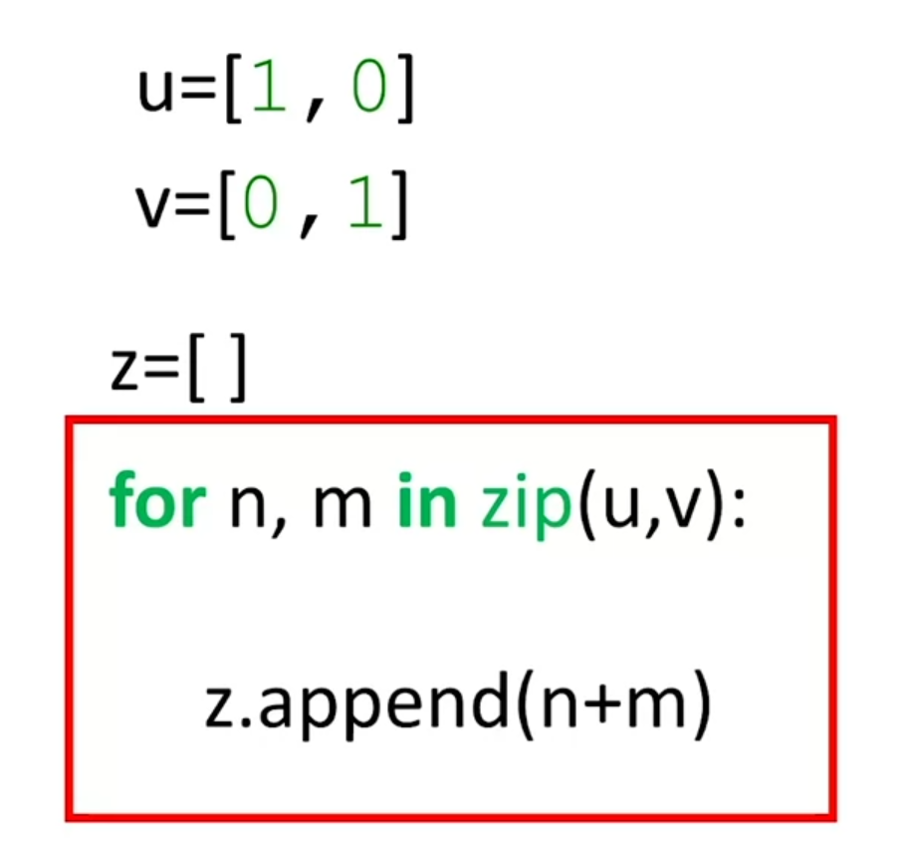

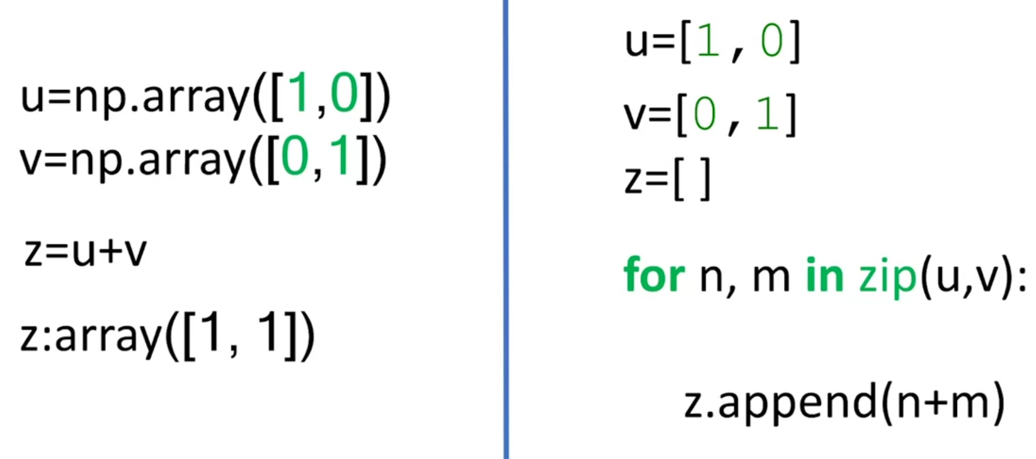

Numpy | and python

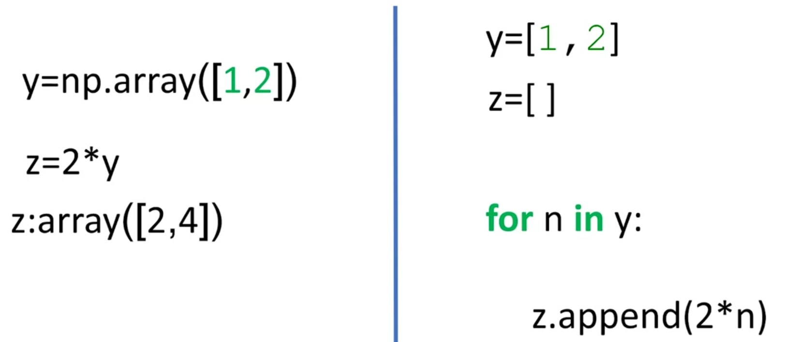

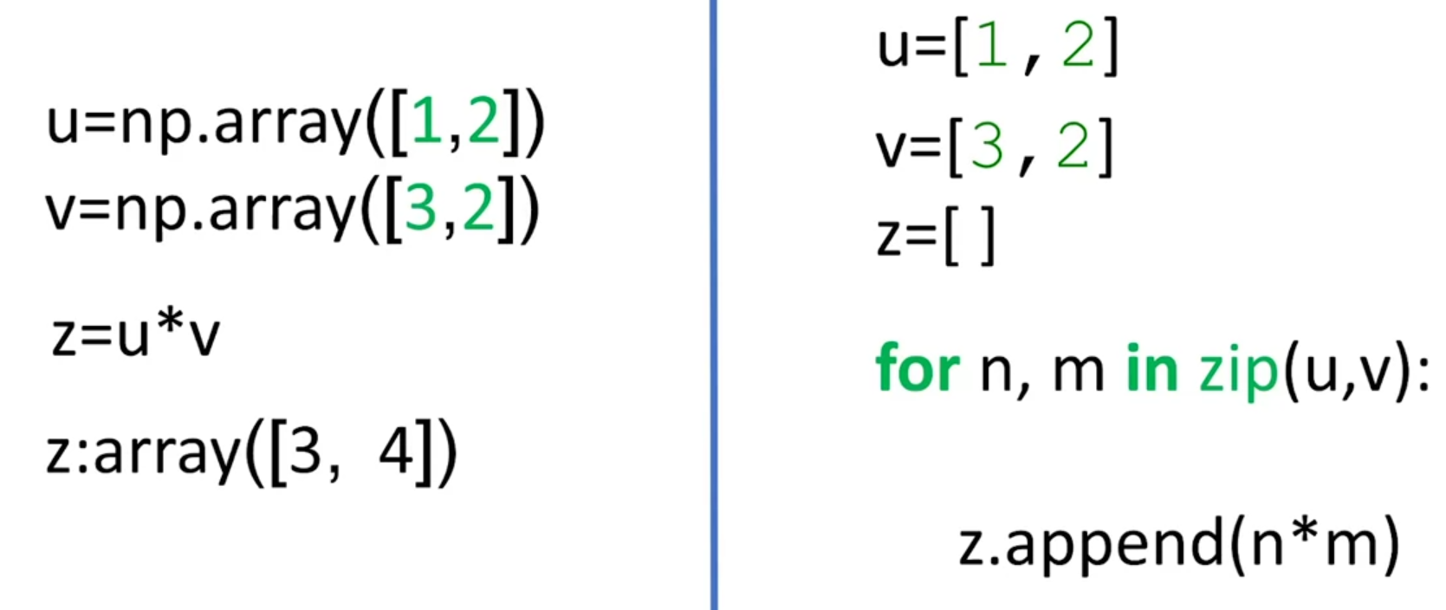

Broadcasting:

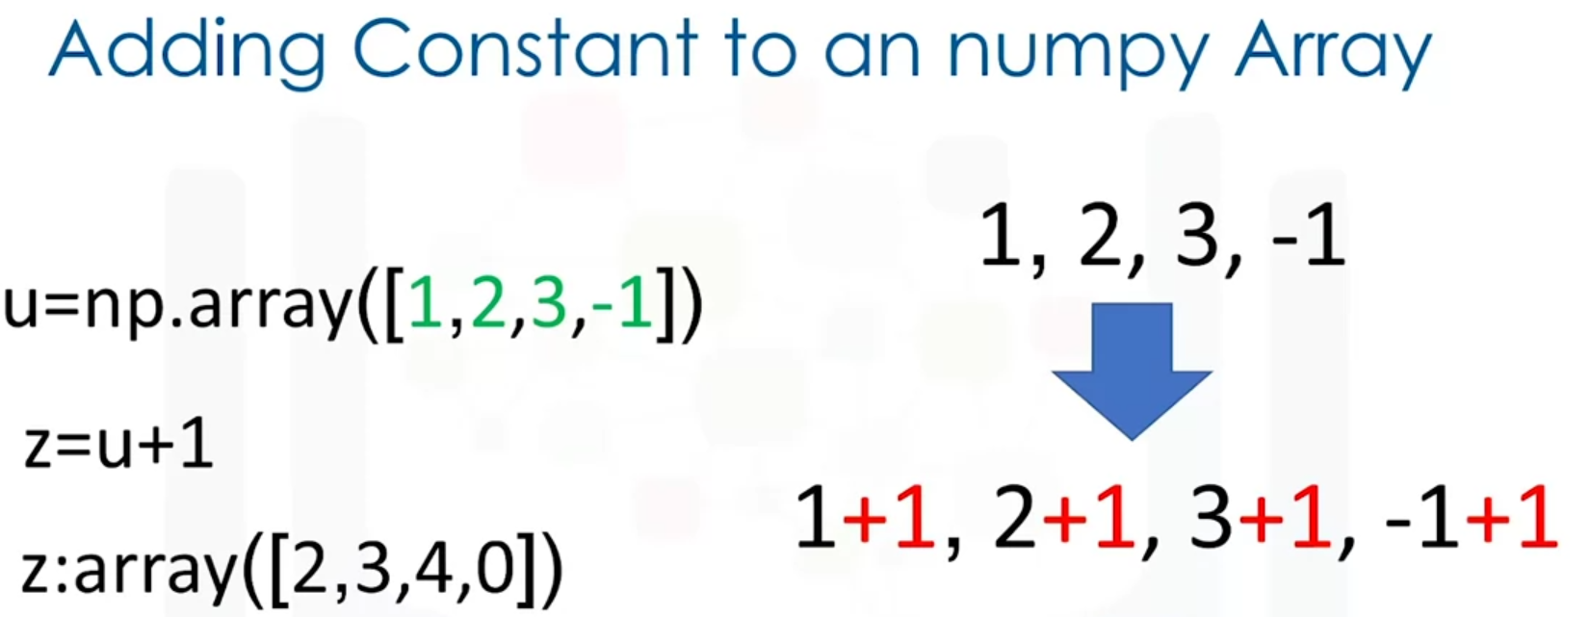

Mean:

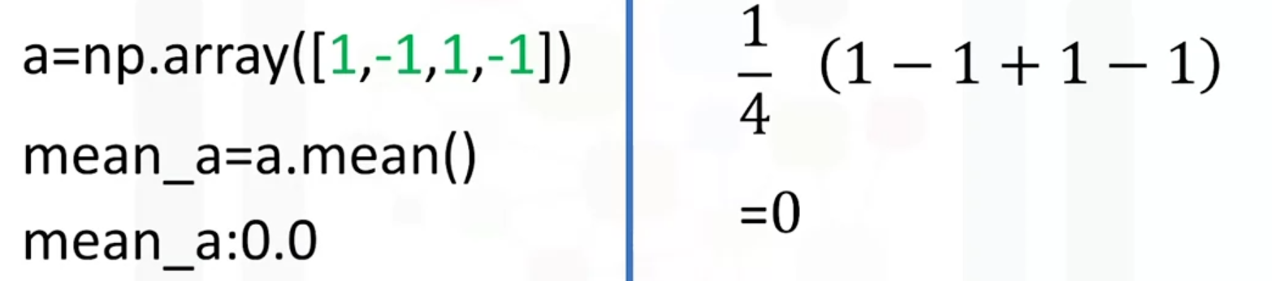

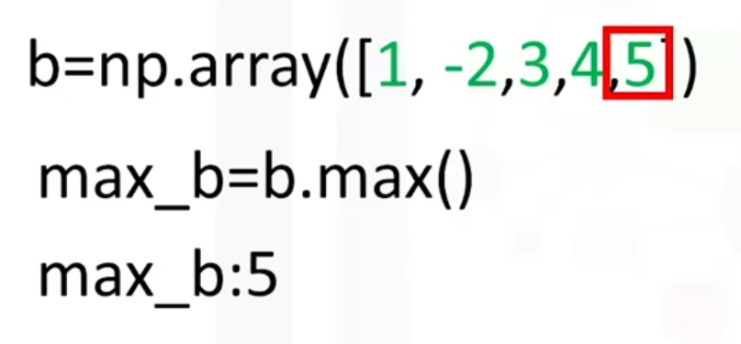

Return evenly spaced numbers over a specified intervals (start/end of the sequence, num of parameters to generate):

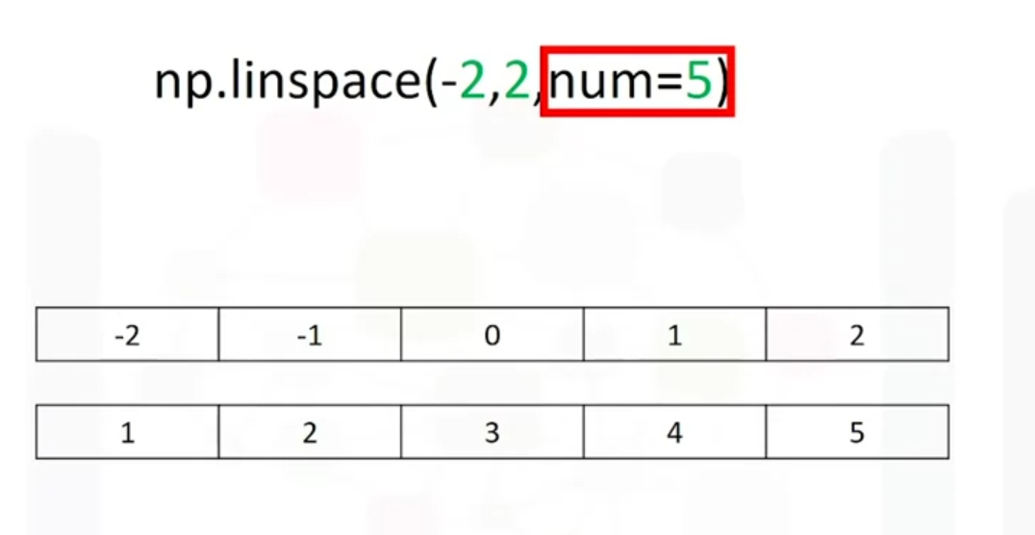

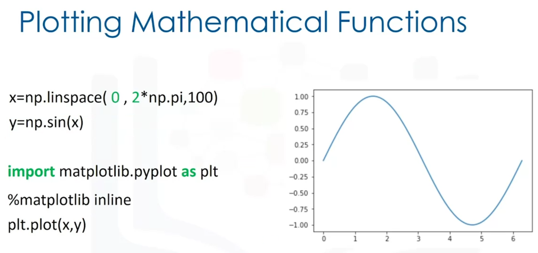

Using select = [2, 3, 4] we can choose which positions in a list you would like to choose:

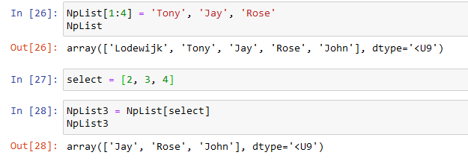

Or you can assign a specific value to these values:

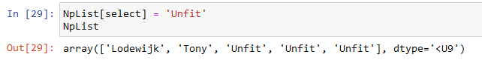

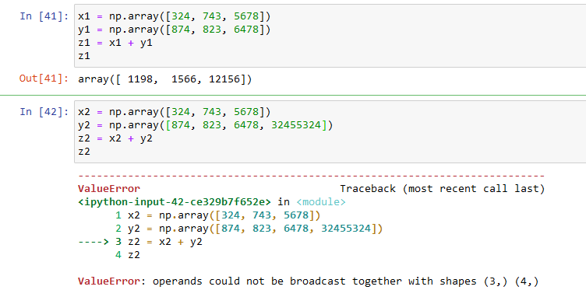

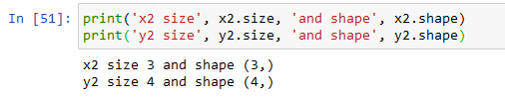

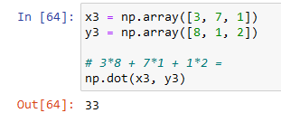

Linspace = begin and end value and how many values in total would you like to see:

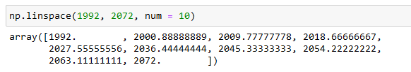

**Two Dimensional Numpy**

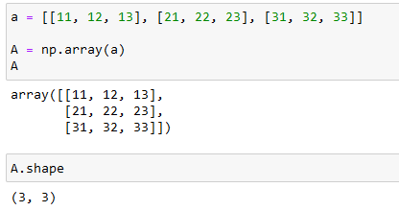

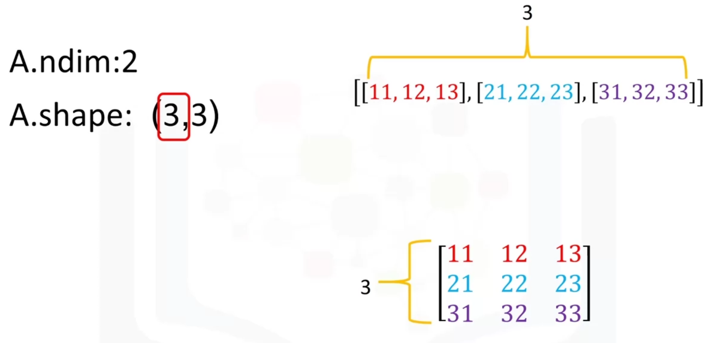

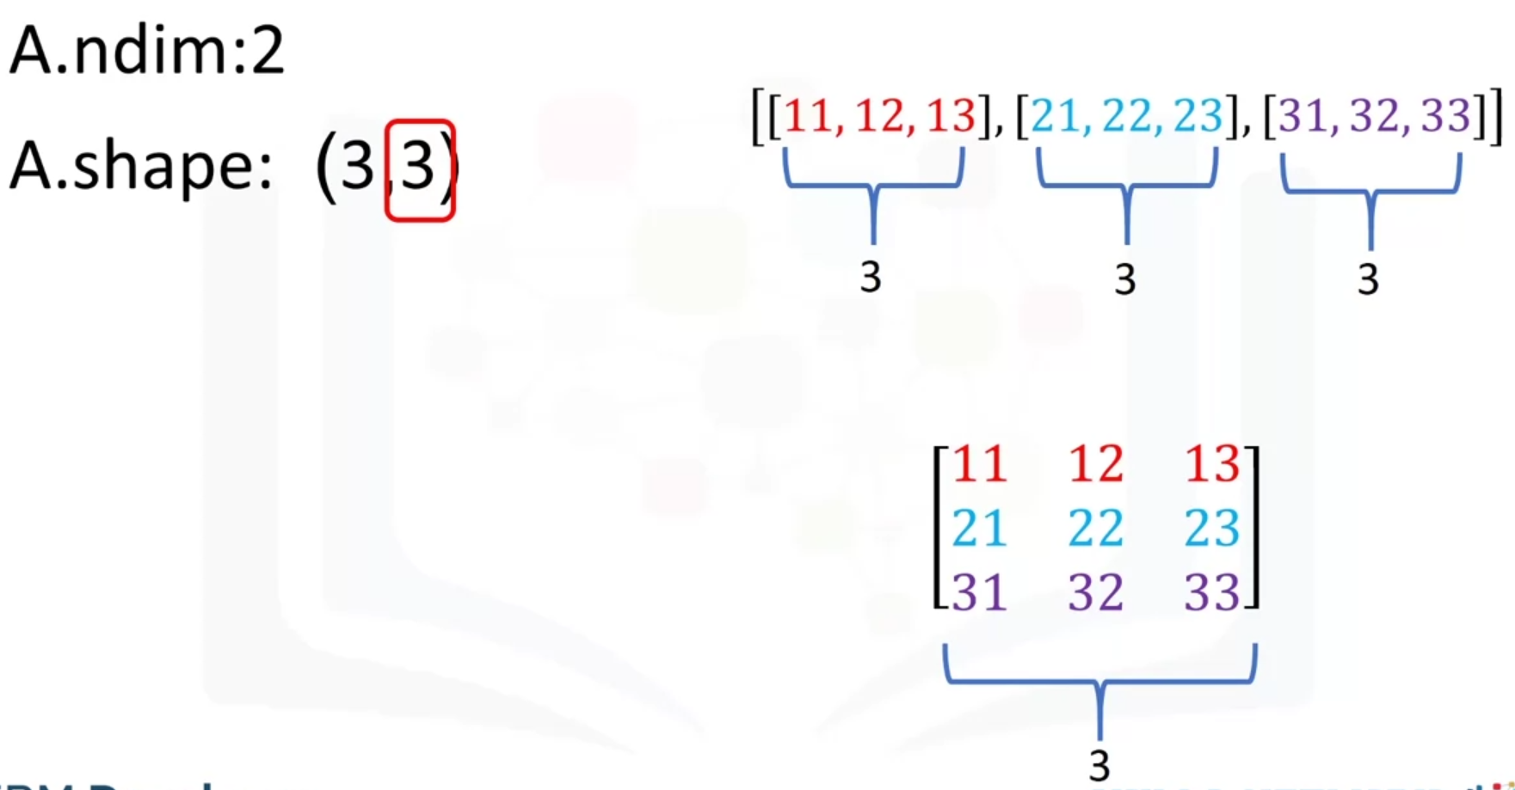

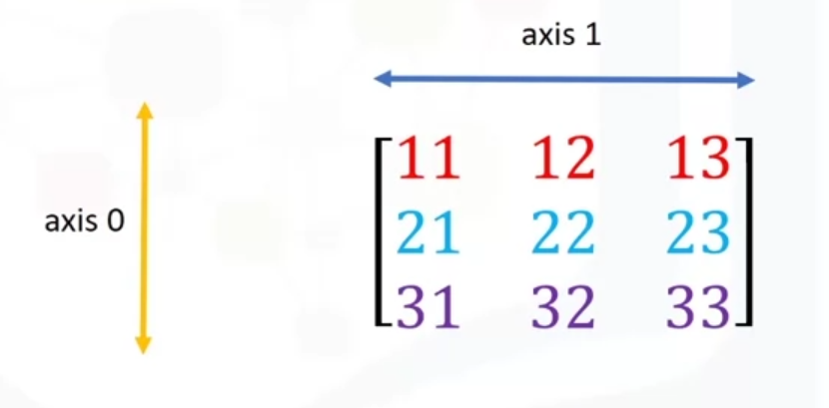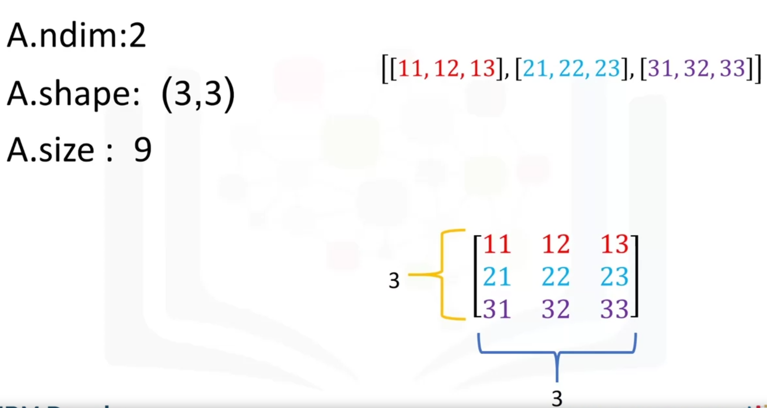

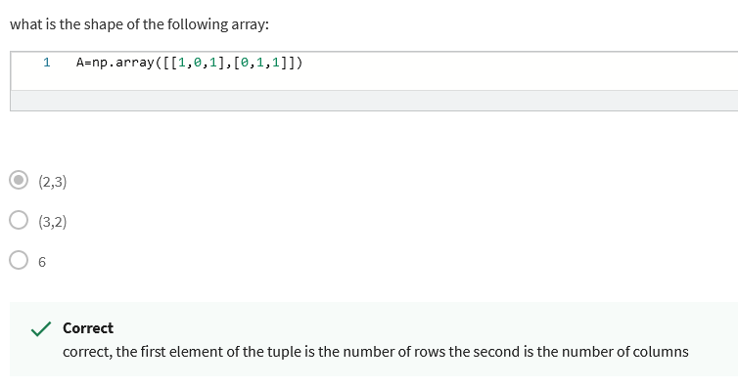

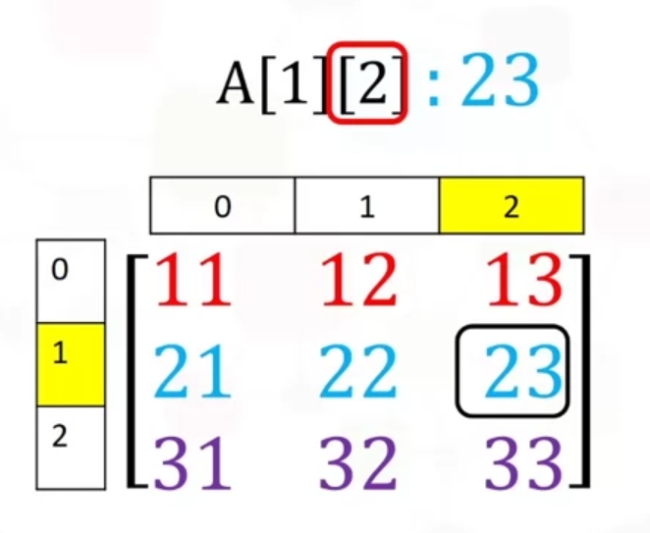

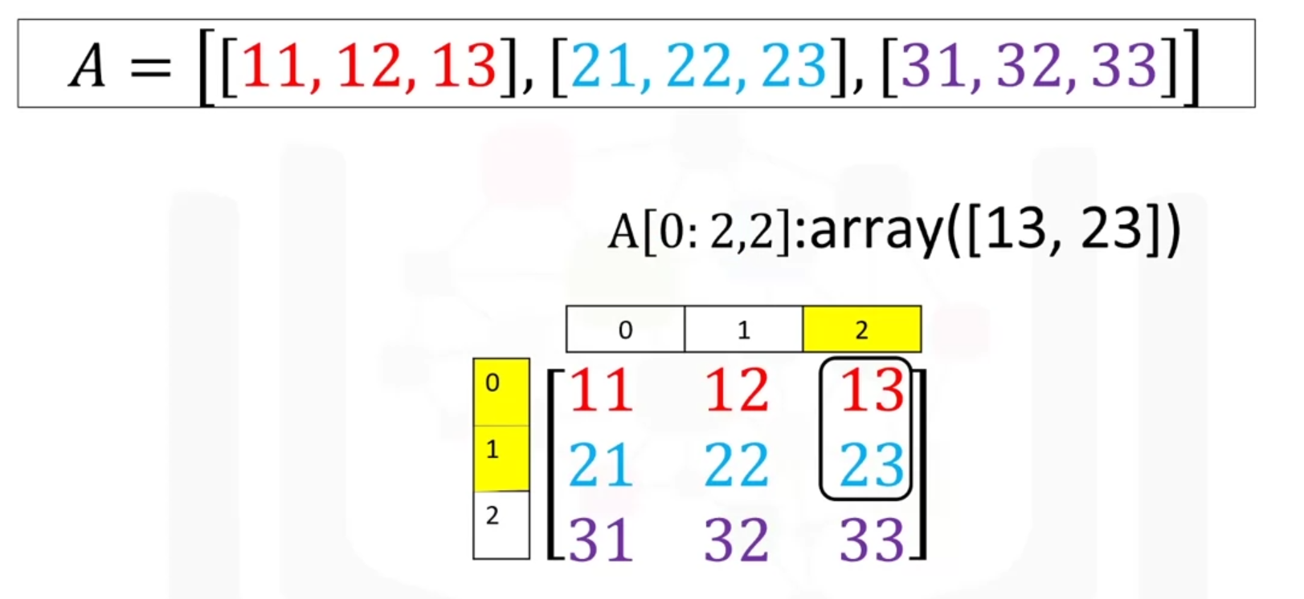

If you have two matrixes that have different shapes, as seen below. In that case use the np.dot(x, y) measure:

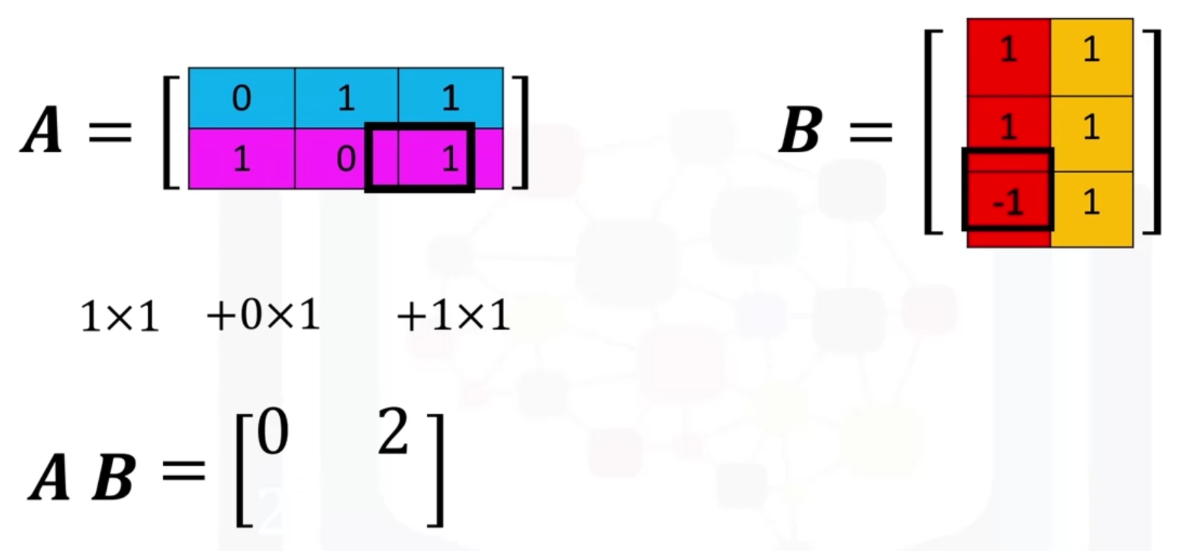

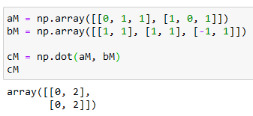

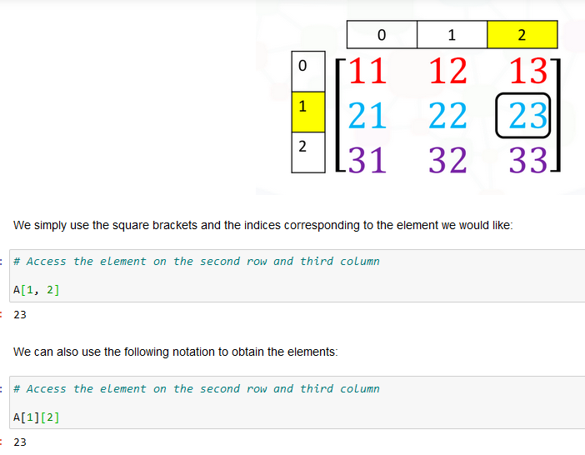

Transpose a matrix:

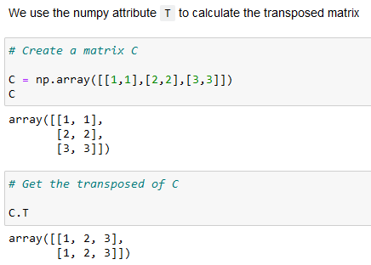

**Week 5**

API = Application Programming Interface

REST APIs = Representational State Transfer APIs

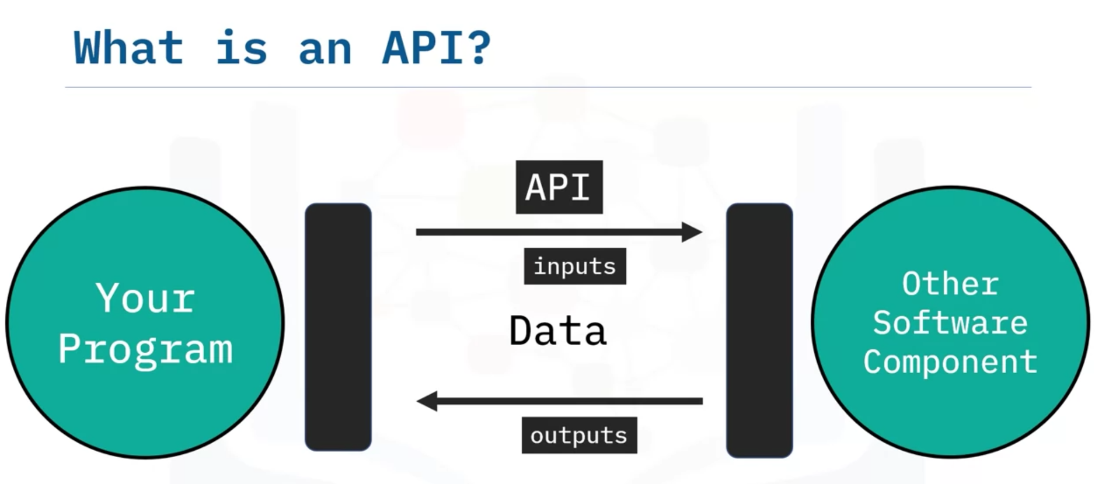

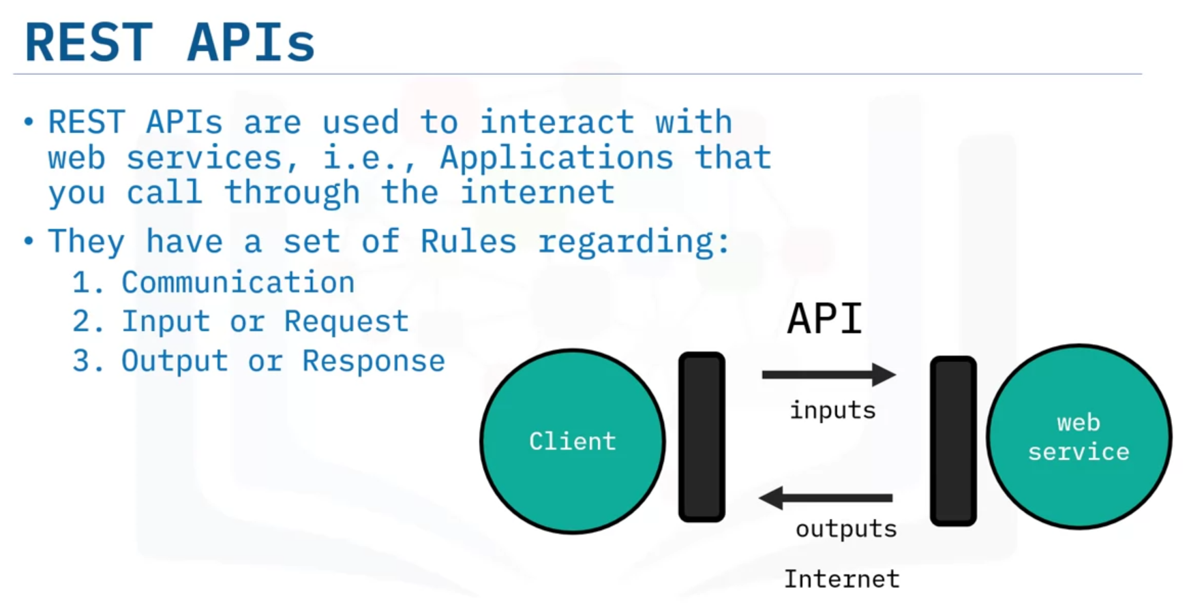

HTTP methods = way of transfer data over the internet.

URL = Uniform Resource Locator

